
FPT- ADCADEMY INTERNATIONAL
FPT – APTECH COMPUTER EDUCATION

Supervisor. | Hoàng Đức Quang
Batch. | T3.2508.E1
Group. | 1
Serial No. | Student Name | Enrollment Number
1 | Tăng Huỳnh Tuấn Tú | Student1685504
2 | Trần Minh Anh
3 | Nguyễn Đức Long | Student1685473

WORK-TRACKER

TP.HCM …..-…..-2026
Contents
PART 1: REVIEW 1 (PHASE 1 - OVERVIEW & SYSTEM REQUIREMENTS) 2
1. PROBLEM STATEMENT 2
CHAPTER 2: FUNCTIONAL & NON-FUNCTIONAL REQUIREMENTS 3
3. SYSTEM REQUIREMENTS (INFRASTRUCTURE CONFIGURATION) 8
4. TASKSHEET 1 (PHASE 1 WORK ALLOCATION & MEMBER CONTRIBUTIONS) 8
PART 2: REVIEW 2 (PHASE 2 - ANALYSIS, DESIGN & DATABASE) 9
1. Use case 9
2. Sequence 11
3. DFD (Data Flow Diagrams) 13
4. ERD (Entity Relationship Diagram) 18
5. Database Data Dictionary (21 Relational Tables) 21
6. Software Architecture 31
7. Tasksheet 2 (Phase 2 Work Allocation & Member Details) 32
PART 3: REVIEW 3 (PHASE 3 - UI SCREEN PREVIEW & FINALIZATION) 33
1. Snapshot screen design (Wireframe) 33
2. Tasksheet review 3 (Details to member) 33
3. Snapshot (Actual System User Interface Screens) 33

PART 1: REVIEW 1 (PHASE 1 - OVERVIEW & SYSTEM REQUIREMENTS)

1. PROBLEM STATEMENT
1.1 WorkTracker Project Introduction
In the context of modern enterprise governance, accurately tracking project progress, managing tasks, and logging work hours play a crucial role in operational efficiency. The WorkTracker system was developed to provide a comprehensive, centralized solution assisting organizations in project management, task assignment, Kanban workflow monitoring, and transparent timesheet period locking.
The system is designed following a modern Client-Server architecture, decoupling the user interface (React Frontend) from the core business logic processing (Django REST Framework Backend), ensuring data security, scalability, and optimal user experience.
1.2 Target Users & System Roles
The WorkTracker system serves 3 primary user groups within an organization:
1. Administrator (Admin): Manages all user accounts, configures departments, defines roles & detailed permissions (RBAC), manages client directory, and monitors audit logs.
2. Manager: Creates and manages projects (Jobs), assigns tasks to employees, monitors Kanban boards, approves work deliverables, reviews timesheets, and executes timesheet period locks.
3. Employee: Updates assigned task statuses, discusses and attaches documents, logs actual daily work hours (Log work), and tracks personal performance reports.
1.3 System Scope & Business Value
* Functional Scope: User management, 2-tier authorization (RBAC), job & task management, interactive Kanban board, work hours logging, monthly timesheet approval & period locking, real-time notifications, and KPI reporting analytics.
* Business Value:
* Optimizing task allocation workflow and enhancing transparency in progress tracking.
* Preventing timesheet fraud (enforcing a 24.0h daily limit and locking past monthly records against retroactive editing).
* Standardizing performance reports to support personnel evaluation and appraisals.

CHAPTER 2: FUNCTIONAL & NON-FUNCTIONAL REQUIREMENTS
2.1 User Functional Requirements (User FRs)
1. Authentication & Access Control Module
▪ FR-01: System Login
Actor: All Users
Description: Allows users to log in using Employee ID/Email and Password, returning a secure JWT authentication token.
▪ FR-02: System Logout
Actor: All Users
Description: Allows users to securely terminate their session and instantly revoke the login access token.
▪ FR-03: Password Recovery via Email
Actor: All Users
Description: Allows users to request a secure password reset link sent to their registered email upon forgetting their password.
▪ FR-04: Change Personal Password
Actor: All Users
Description: Allows users to proactively change their password after verifying their current password.
▪ FR-05: Role-Based Access Control (RBAC)
Actor: All Users
Description: Allows the system to automatically enforce permission boundaries and interface views based on user roles (Admin, Manager, Employee).
2. User Account & Profile Management Module
▪ FR-06: View Personal Profile
Actor: All Users
Description: Allows users to view personal profile details, department, job title, email, and contact phone number.
▪ FR-07: Update Personal Profile
Actor: All Users
Description: Allows users to update profile avatar, phone number, and personal contact information.
▪ FR-08: User Directory Management
Actor: Admin
Description: Allows Admin to view, search, and filter the entire user directory by department, role, and active status.
▪ FR-09: Create & Update User Accounts
Actor: Admin
Description: Allows Admin to create new employee accounts, assign roles, assign departments, and update personnel details.
▪ FR-10: Deactivate / Reactivate Accounts
Actor: Admin
Description: Allows Admin to deactivate user accounts (instantly block login) or reactivate accounts for employees.
3. Department & Organization Directory Module
▪ FR-11: Department Directory Management
Actor: Admin
Description: Allows Admin to create, edit, update descriptions, and manage organization department structures.
▪ FR-12: Employee Directory Lookup
Actor: All Users
Description: Allows users to search colleague contact information by name, department, or job title.
4. Client / Partner Management Module
▪ FR-13: Client List Management
Actor: Admin, Manager
Description: Allows creating and updating Client/Partner details (Client Code, Company Name, Tax Code, Contact Person, Phone).
▪ FR-14: Client Information Lookup
Actor: Admin, Manager
Description: Allows viewing historical and ongoing projects associated with each Client.
5. Core Job & Project Management Module
▪ FR-15: Job & Project Management
Actor: Admin, Manager
Description: Allows creating new projects, assigning responsible Manager, selecting Client, setting start/end dates, and allocated timeframe budget.
▪ FR-16: Assign Project Manager
Actor: Admin
Description: Allows Admin to assign or reassign the primary responsible Manager for each project.
6. Task & Kanban Workflow Management Module
▪ FR-17: Monitor Progress on Kanban Board
Actor: Manager, Employee
Description: Allows tracking and drag-and-drop task status updates across interactive Kanban columns (TODO, IN_PROGRESS, REVIEW, DONE, CANCELED).
▪ FR-18: Submit Work Completion Report
Actor: Employee
Description: Allows Employees to submit task completion reports with result notes for Manager review and approval.
▪ FR-19: Two-Tier Review: Task Deliverables QA Inspection & Acceptance
Actor: Manager
Description: Implements Tier-1 Quality Assurance review. Allows Managers to inspect submitted deliverable packages (.zip, .pdf, design assets) with 1-click downloads, compare Original Acceptance Criteria against Assignee Handover Notes, perform auto-advance queue signoff (REVIEWING -> COMPLETED), or return tasks for rework (IN_PROGRESS) with mandatory fix instructions and optional reference guide material attachments.
▪ FR-20: Task Discussions & Attachments
Actor: Manager, Employee
Description: Allows Employee and Manager to exchange comments, post feedback, and attach documents/images directly within each task.
▪ FR-21: Task Follower System
Actor: Manager, Employee
Description: Allows users to subscribe to critical tasks to automatically receive real-time notifications upon new comments, status changes, or document attachments.
7. Timesheet & Time Lock Control Module
▪ FR-22: Work Hours Logging (Log Work)
Actor: Employee
Description: Allows Employees to accurately log actual work hours spent on assigned tasks during the day along with detailed activity descriptions.
▪ FR-23: Two-Tier Review: Timesheet Effort Cockpit & LogWork Verification
Actor: Manager
Description: Implements Tier-2 Effort Audit review. Allows Managers to audit actual claimed work hours via a fixed 2-column Split-Pane Master-Detail cockpit (56%/44% responsive ratio). Displays prominent hours hero banners, multi-day historical log breakdowns per task (Daily Log History Timeline), seamless auto-advance approval queues with zero-pending empty state transitions, and sticky action footers for 100% desktop/laptop screen compatibility.
▪ FR-24: Timesheet Period Lock (Time Lock)
Actor: Manager, Admin
Description: Allows authorized managers to execute monthly/yearly timesheet period locks. Once locked, no user can create, edit, or delete work logs in that period.
▪ FR-25: Unlock Timesheet Period
Actor: Manager, Admin
Description: Allows authorized personnel to unlock previously locked timesheet periods requiring mandatory reason entry for data adjustment during audit incidents.
8. Real-time Notifications & Discussion Module
▪ FR-26: View & Manage Notifications
Actor: All Users
Description: Enables Managers to initiate immediate 1-on-1 conversations with assigned employees during task inspection via a non-intrusive floating chat window without navigating away from the QA review interface, with messages automatically synced to global chat history.
Actor: Manager
▪ FR-26A: Real-time 1-on-1 Direct Chat & Project Channels (Team Chat)
Description: Allows users to view real-time notification list, mark as read, and inspect historical event trails.
9. Reporting, Analytics & Data Export Module
▪ FR-26B: Instant Task-Context Quick Chat
Description: Supports persistent real-time messaging via WebSockets (Django Channels & Redis) across 1-on-1 direct rooms and project-specific channels. Features instant message delivery, live online presence, attachment file sharing, and full synchronization across the standalone Team Chat center and task inspection popups.
Actor: Manager, Employee, Admin
▪ FR-27: View KPI Charts & Performance Reports
Actor: Admin, Manager, Employee
Description: Allows users to view visual charts and metric cards detailing work hours, task progress, and personal performance metrics.
▪ FR-28: Export Data Reports
Actor: Admin, Manager
Description: Allows users to export timesheet data, project progress, and employee performance to standard document formats (Excel spreadsheets or PDF files).
10. System Logs & Audit Module
▪ FR-29: View Operation Logs (Audit Logs)
Actor: Admin
Description: Allows Admin to inspect system audit logs tracking operation history (who executed, timestamp, changed attributes) and compare diffs.
2.2 System Non-Functional Requirements (System NFRs)
▪ NFR-01: API Response Performance
Measurement Criteria: API response time < 2.0s for 95% of requests under normal load conditions.
Technical Solution: Query optimization (select_related, prefetch_related) and Redis Caching for static lookup data.
▪ NFR-02: Dashboard Page Load Speed
Measurement Criteria: Dashboard complete page load and rendering time < 3.0 seconds.
Technical Solution: Client-side state caching in React frontend and parallel KPI computation at Backend.
▪ NFR-03: Database Indexing Optimization
Measurement Criteria: 100% of core search and filter database queries execute via Database Indexing.
Technical Solution: Create B-Tree indexes on high-frequency search fields (project code, task ID, status, manager ID, deadline).
▪ NFR-04: Password Encryption & Token Security
Measurement Criteria: 100% of stored passwords hashed; Access tokens instantly revoked upon logout.
Technical Solution: Employ PBKDF2/Argon2 hashing for passwords and secure JWT access/refresh token lifecycle management.
▪ NFR-05: Dual-Layer Authorization & Scope Control
Measurement Criteria: Zero cross-tenant or cross-department data leakage between Managers or Employees.
Technical Solution: Enforce 2-tier authorization checks at Backend: Tier 1 checks operation permission code, Tier 2 enforces object-level ownership scoping.
▪ NFR-06: OWASP Top 10 Security Compliance
Measurement Criteria: Full security compliance protecting against SQL Injection, XSS, and CSRF vulnerabilities.
Technical Solution: Django ORM auto-parameterizes queries against SQLi; React frontend sanitizes input strings against XSS.
▪ NFR-07: Test Reliability & Automation Coverage
Measurement Criteria: Automated test suite pass rate reaches 100% (Pass Rate = 100%).
Technical Solution: Build automated test suite of 109 test cases validating all business flows prior to packaging.
▪ NFR-08: Real-time & Async Infrastructure Availability
Measurement Criteria: Ensure notification dispatch and background task infrastructure availability > 99.5%.
Technical Solution: Utilize WebSockets (Django Channels) for real-time notifications and Celery + Redis for asynchronous task queues.

3. SYSTEM REQUIREMENTS (INFRASTRUCTURE CONFIGURATION)
3.1 Server Environment
* CPU: Minimum Intel Core i5 / Xeon (4 Cores) — *Recommended: Intel Core i7 / Xeon (8 Cores)*
* RAM: Minimum 8 GB — *Recommended: 16 GB*
* Storage: Minimum 100 GB SSD — *Recommended: 250 GB SSD NVMe*
* Operating System: Ubuntu Server 22.04 LTS / Windows Server 2019
3.2 Client / End-User Environment
* CPU: Minimum Intel Core i3 / AMD Ryzen 3 — *Recommended: Intel Core i5 or higher*
* RAM: Minimum 4 GB — *Recommended: 8 GB or higher*
* Display: Minimum resolution 1366x768 — *Recommended: Full HD (1920x1080)*
* Browser: Google Chrome, MS Edge, Firefox, Safari (Latest Versions)

4. TASKSHEET 1 (PHASE 1 WORK ALLOCATION & MEMBER CONTRIBUTIONS)
Description: Detailed work and progress allocation table for team members during Review 1 phase.
[Insertion Placeholder - Tasksheet 1 Work Allocation Table for Review 1]

PART 2: REVIEW 2 (PHASE 2 - ANALYSIS, DESIGN & DATABASE)

1. Use case
1.1 Overview Use Case Diagram
The WorkTracker system includes key Use Case packages categorized by 3 primary Actors:
• Admin: User Management, RBAC Authorization, Department Configuration, Client Management, Global Time Lock/Unlock, and Audit Logs Inspection.
• Manager: Job Creation, Task Allocation, Work Deliverable Approval, Job-scope Time Lock/Unlock, Log Work Review, and Report Export.
• Employee: Kanban Board Progress Update, Comments & File Attachments, Daily Log Work Entry, and Personal Performance Report Lookup.
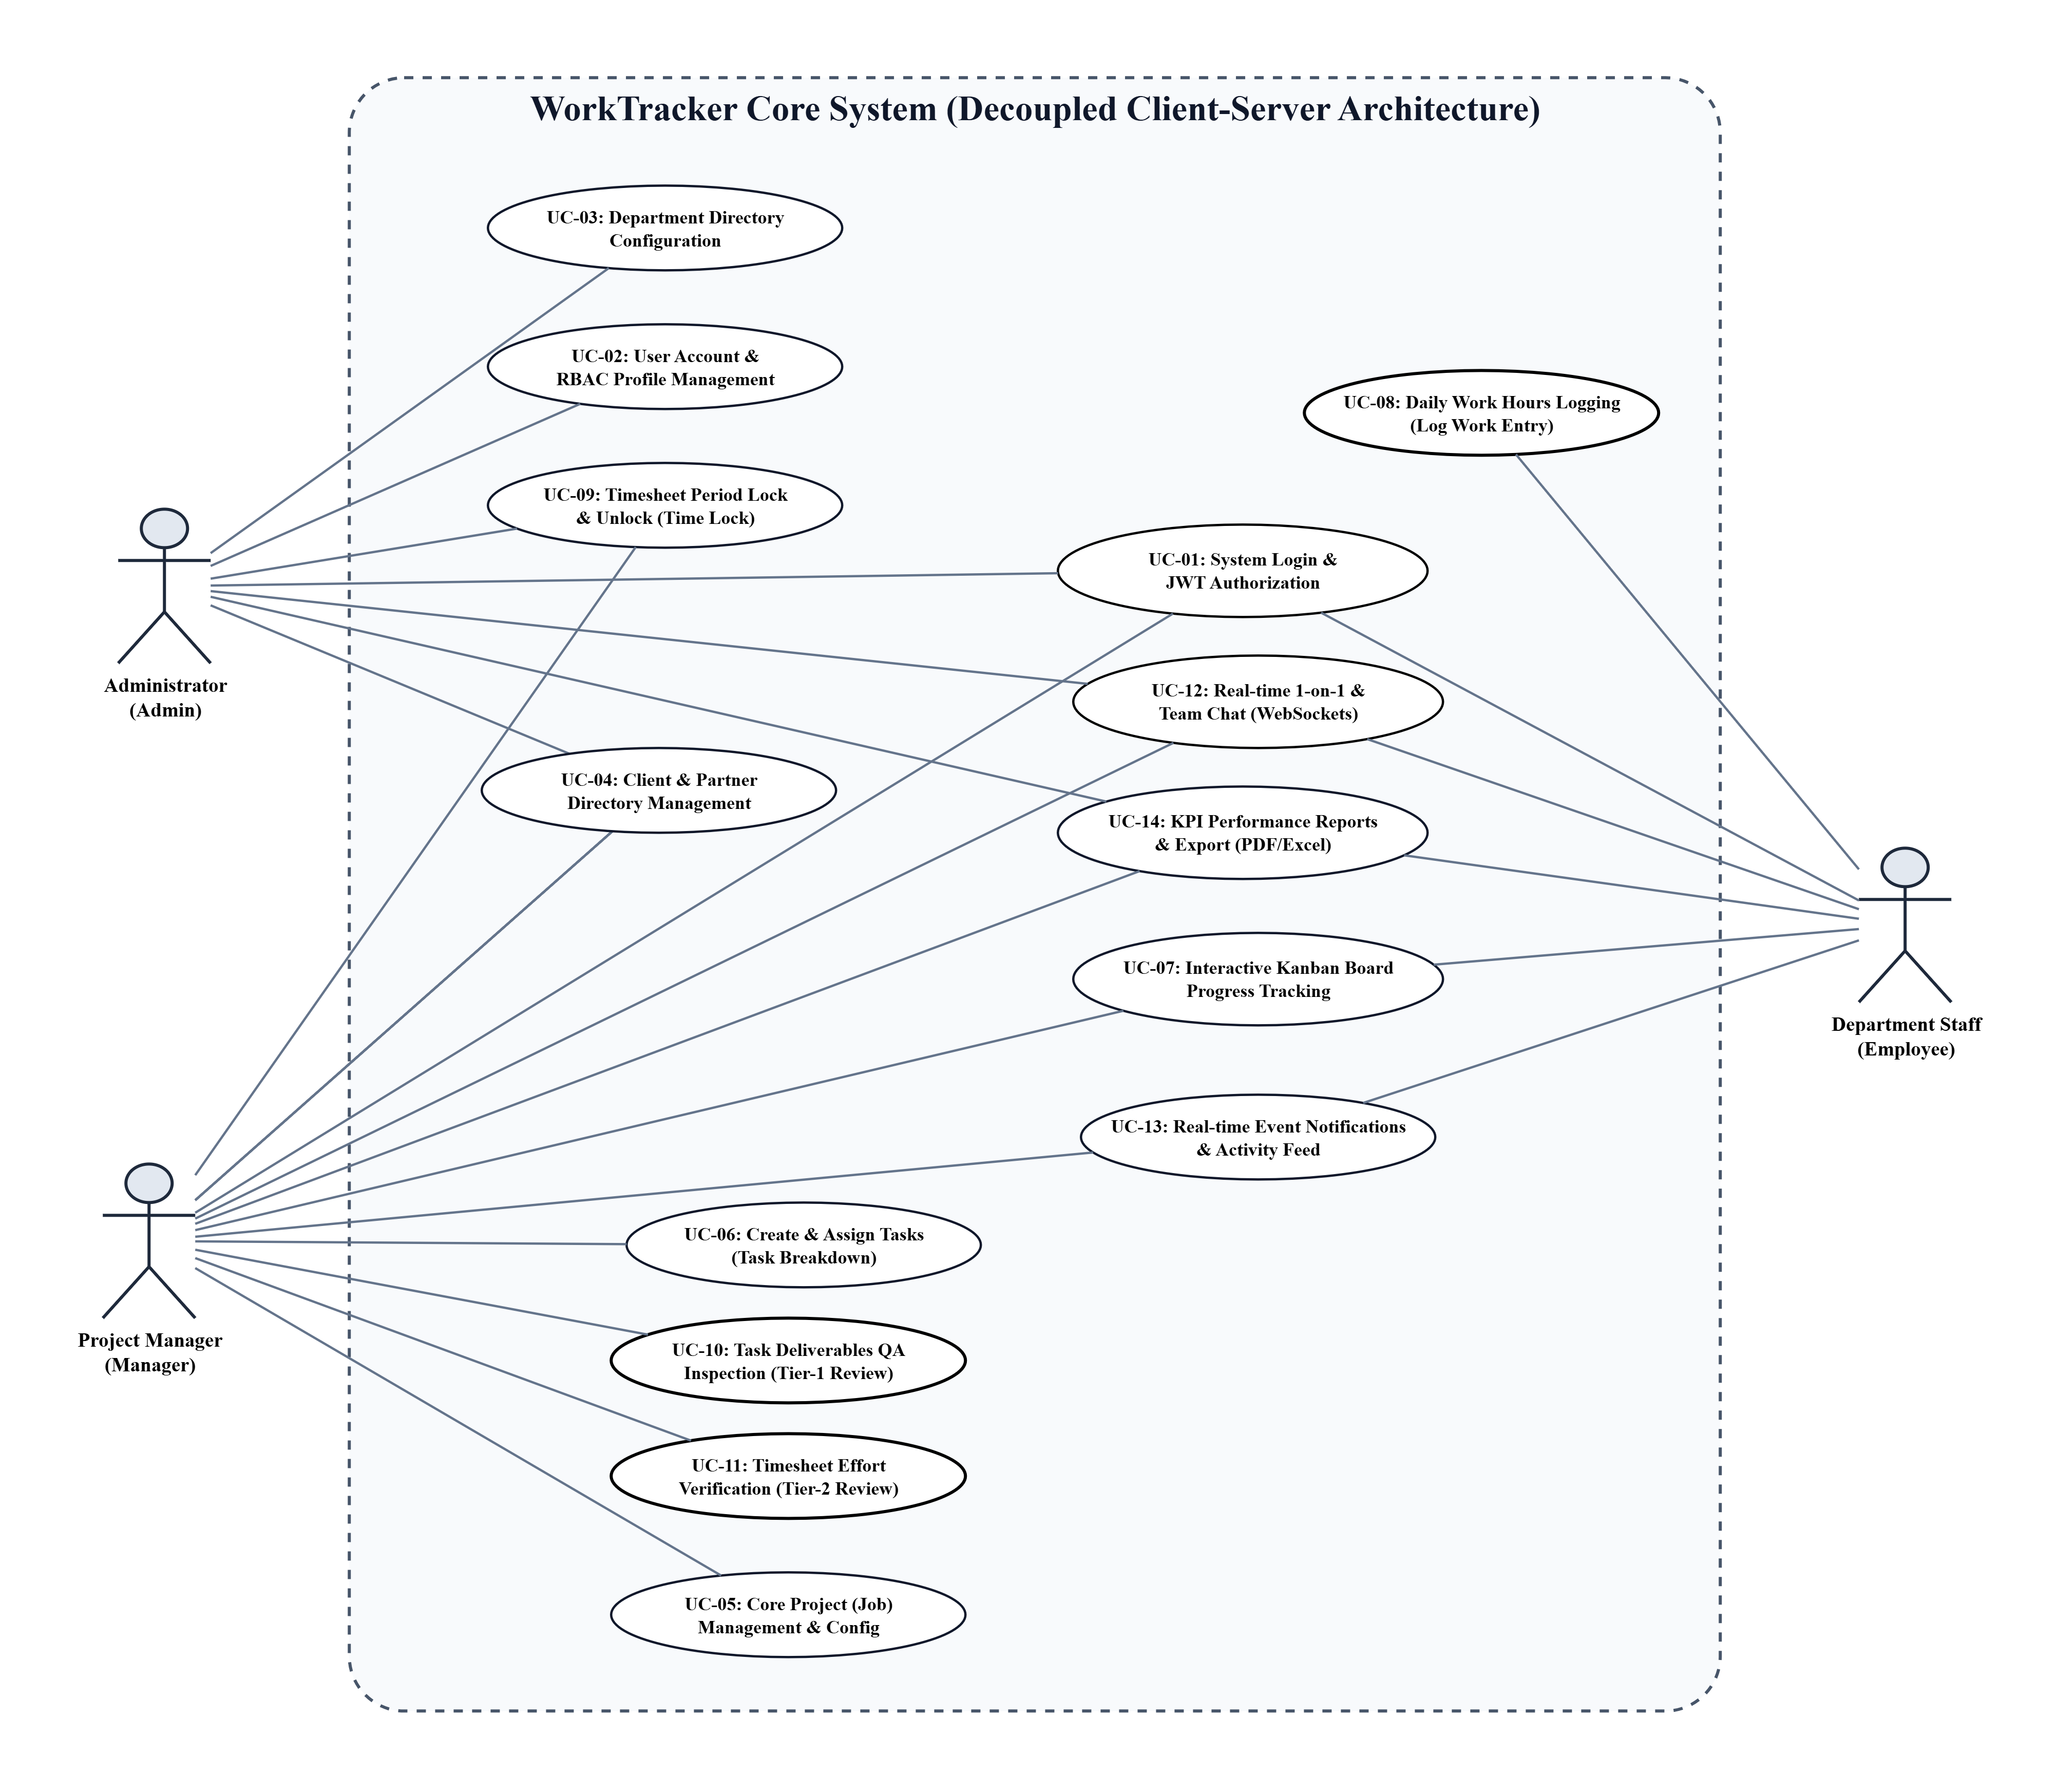

1.2 Detailed Specifications of Key Use Cases
UC-01: System Login & JWT Authorization
• Actor: All Users (Admin, Manager, Employee).
• Purpose: Authenticate user credentials and issue role-based JWT tokens.
• Prerequisites: User account is provisioned and active (is_active = True).
• Main Flow: User enters email/password -> System validates credentials -> Backend issues Access/Refresh tokens -> Client redirects to Role Dashboard.
• Exception Flow: Invalid credentials or deactivated account prompts error message.
• Postconditions: Authenticated session established with assigned role permissions.

UC-02: User Account & Profile Management
• Actor: Admin (Manage accounts), All Users (Update profile).
• Purpose: Provision employee accounts, assign roles/departments, and update personal profile.
• Prerequisites: Admin authorization for account CRUD; active account for profile update.
• Main Flow: Admin creates account with email, role, department -> System sends activation -> User logs in to update avatar and contact phone.
• Postconditions: User account and profile synchronized in users and employee_profiles tables.

UC-03: Department & Organization Directory Management
• Actor: Admin.
• Purpose: Configure company department structures and assign department managers.
• Prerequisites: Admin administrative privileges.
• Main Flow: Admin accesses Department Directory -> Enters department name, code, and lead manager -> System saves record.
• Postconditions: Department structure updated and linked to employee assignments.

UC-04: Client & Partner Directory Management
• Actor: Admin, Manager.
• Purpose: Create and maintain client/partner profiles for project billing and contracts.
• Prerequisites: Admin or Manager authorization.
• Main Flow: User enters Client Name, Tax Code, Contact Email, Phone -> System commits client profile.
• Postconditions: Client profile saved and available for project (Job) assignment.

UC-05: Core Project (Job) Management & Configuration
• Actor: Admin, Manager.
• Purpose: Initialize projects, assign responsible Managers, set timelines, and budget hours.
• Prerequisites: Target Client profile created; Manager selected.
• Main Flow: User clicks 'Create Job' -> Selects Client, Manager, start/end dates, timeframe budget -> System creates Job record.
• Postconditions: Project created and available for task breakdown and timesheet tracking.

UC-06: Create & Assign Tasks (Task Breakdown)
• Actor: Manager.
• Purpose: Create tasks under managed projects, set acceptance criteria, and assign to staff.
• Prerequisites: Project initialized; Manager holds assignment permissions.
• Main Flow: Manager selects project -> Inputs title, description, assignee, deadline, priority -> System validates and creates task with status 'TODO'.
• Postconditions: Task rendered on Kanban Board and assigned to employee's backlog.

UC-07: Interactive Kanban Board Progress Tracking
• Actor: Manager, Employee.
• Purpose: Update and visualize task workflow stages via interactive drag-and-drop.
• Prerequisites: Task exists in project workflow.
• Main Flow: User drags task card across columns (TODO -> IN_PROGRESS -> REVIEWING -> COMPLETED) -> System updates status and LexoRank index.
• Postconditions: Task status updated in real-time across team dashboards.

UC-08: Work Hours Logging (Log Work)
• Actor: Employee.
• Purpose: Log actual daily hours spent on assigned tasks with work descriptions.
• Prerequisites: Task active; target date period is not locked by Time Lock.
• Main Flow: Employee selects task -> Enters work date, hours, activity description -> System validates (daily total <= 24h, unlocked period) -> Commits log_works entry.
• Exception Flow: Exceeding 24h/day or logging into locked periods is strictly rejected.
• Postconditions: Work hours recorded and aggregated into daily timesheet.

UC-09: Timesheet Period Lock & Unlock (Time Lock)
• Actor: Manager (Job Scope), Admin (Global Scope).
• Purpose: Freeze timesheet periods to finalize payroll and prevent retrospective tampering.
• Prerequisites: User possesses Time Lock administrative permissions.
• Main Flow: User selects month/year and scope -> Clicks 'Lock Period' -> System commits time_locks record and blocks all log work mutations for that timeframe.
• Postconditions: Timesheet records for the period are immutably locked.

UC-10: Task Deliverables QA Inspection & Acceptance (Tier-1 Review)
• Actor: Manager.
• Purpose: Review submitted employee deliverables, verify acceptance criteria, and approve or return for rework.
• Prerequisites: Task status is 'REVIEWING' with submitted handover files.
• Main Flow: Manager opens QA Queue (/manager/tasks/review) -> Downloads handover files -> Compares with criteria -> Clicks 'Approve' (transitions to COMPLETED) or 'Reject' (adds fix notes & reference guide, returns to IN_PROGRESS).
• Postconditions: Deliverables accepted or returned with rework audit trail.

UC-11: Timesheet Effort Verification & Approval (Tier-2 Review)
• Actor: Manager.
• Purpose: Audit and approve employee claimed work hours via Split-Pane effort cockpit.
• Prerequisites: Employee has submitted work logs pending review.
• Main Flow: Manager opens Timesheet Review page -> Audits claimed hours via Daily Log History timeline -> Clicks 'Approve' -> Queue auto-advances until all records cleared.
• Postconditions: Work logs marked 'APPROVED' for payroll aggregation.

UC-12: Real-time 1-on-1 & Team Chat (WebSockets)
• Actor: All Users (Admin, Manager, Employee).
• Purpose: Enable instant messaging, task discussions, and attachment file sharing.
• Prerequisites: User authenticated; target user or project channel exists.
• Main Flow: User opens Chat page or Task Quick Chat popup -> WebSocket connects via Django Channels & Redis -> Sends text/file -> Broadcasted in sub-100ms to recipients.
• Postconditions: Message delivered instantly and saved in persistent chat history.

2. Sequence
2.1 Sequence Diagram: Login Flow & JWT Authentication
Describes sequence of interactions between Client (React), API Gateway/Controller, Service Layer, and Database during login authentication flow.

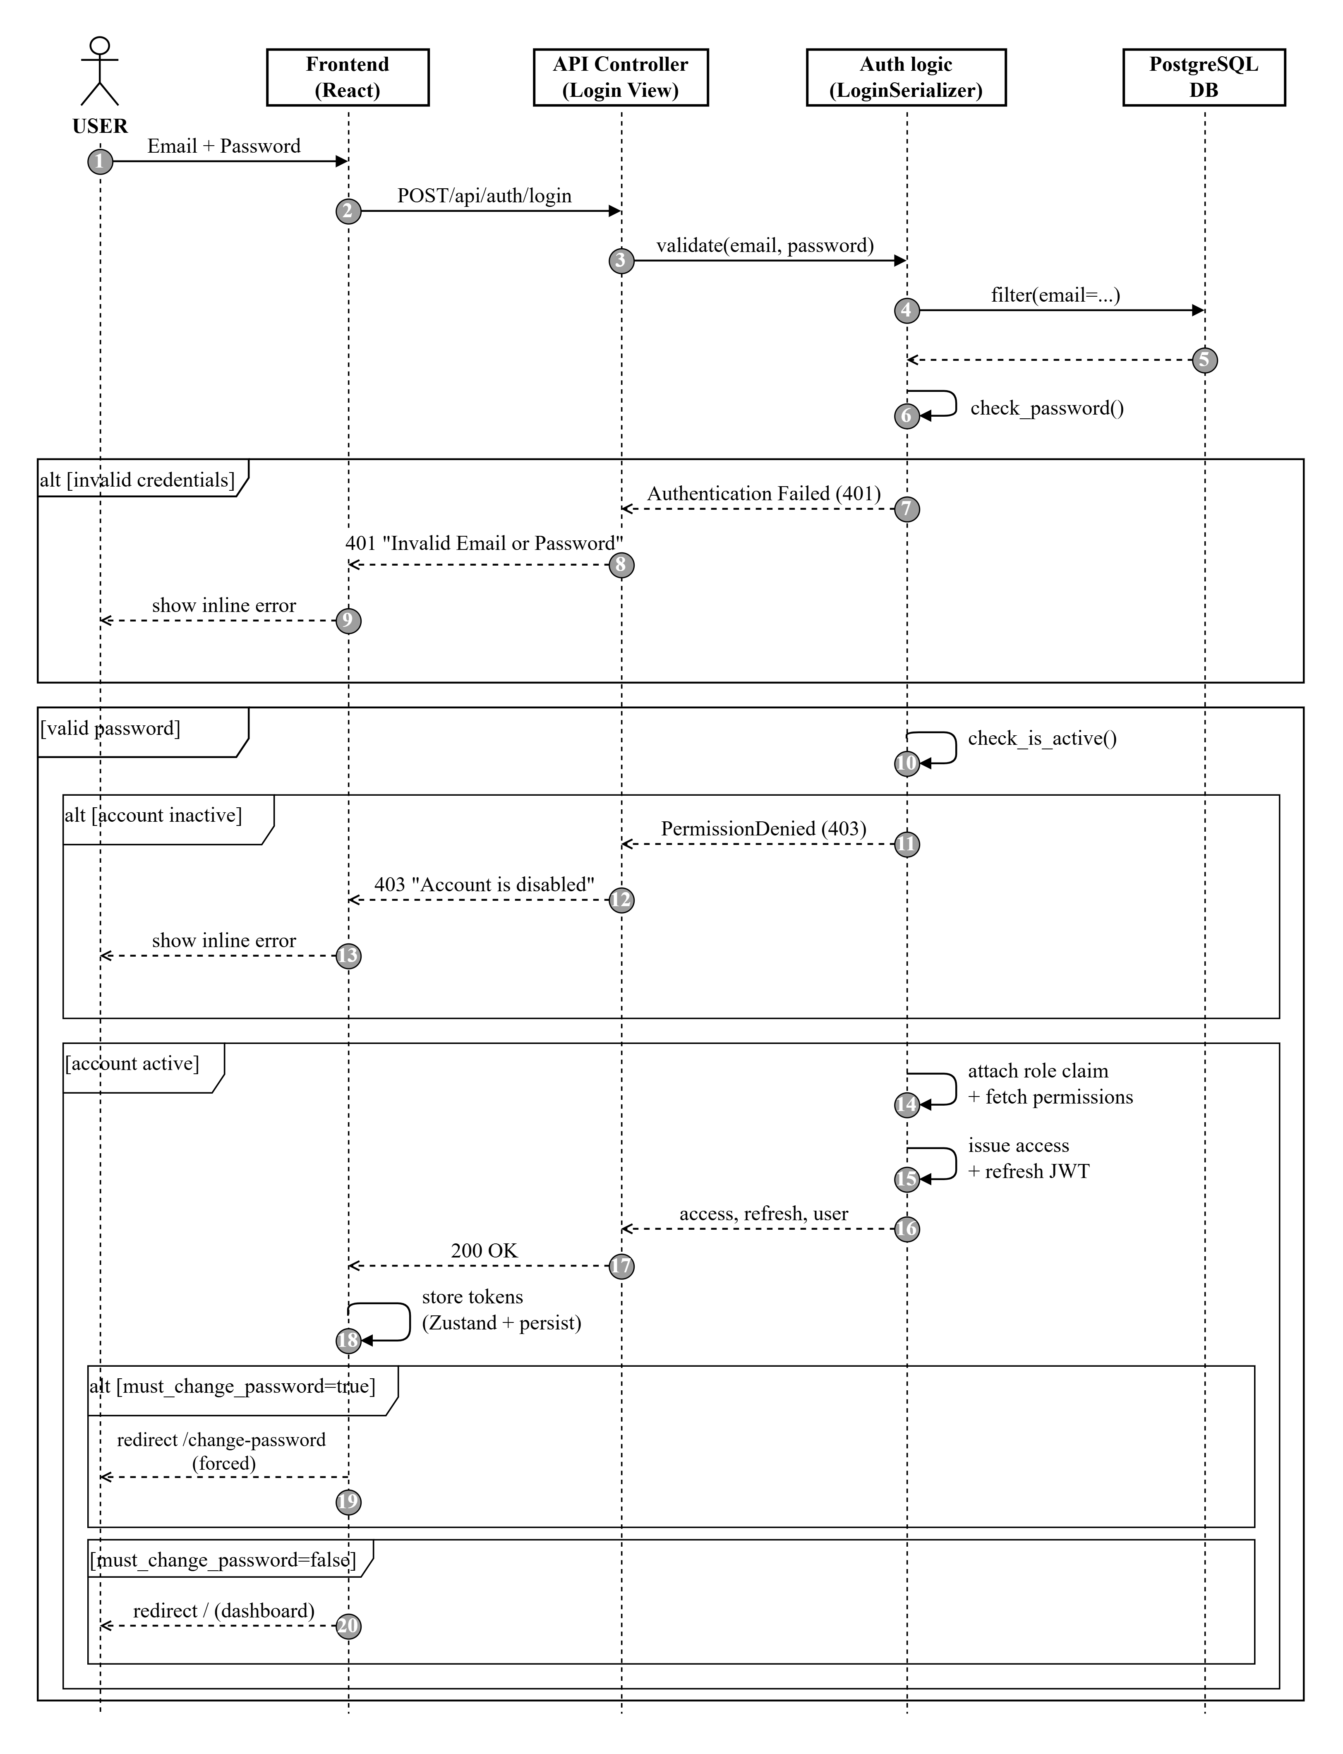
2.2 Sequence Diagram: Timesheet Entry (Log Work) Flow
Describes strict 2-tier constraint validation sequence executed when employee submits work hours log.
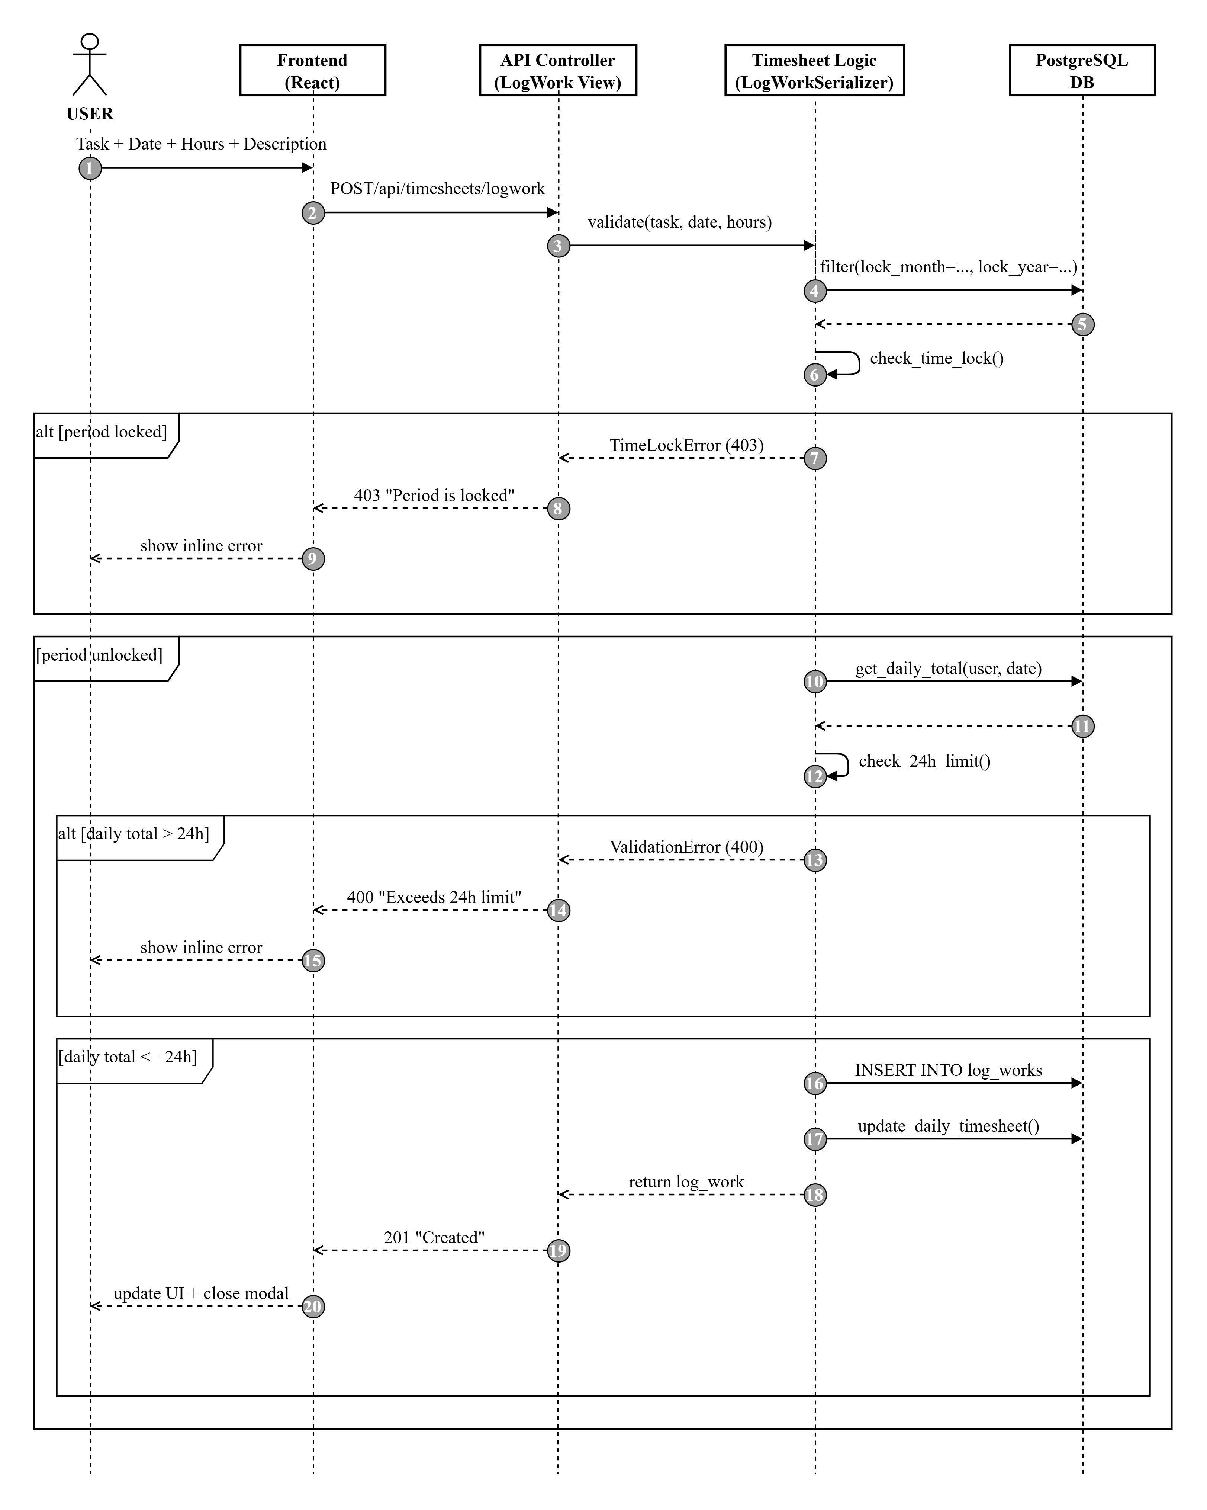

3. DFD (Data Flow Diagrams)
3.1 DFD Level 0 (Context Diagram)
Diagram Description: DFD Level 0 (Context Diagram) illustrates the overall interaction between external Actors (Admin, Manager, Employee) and the WorkTracker Core System, mapping input data flows (Credentials, Task Creation, Log Work, Time Lock commands) and output data flows (Real-time Notifications, KPI Reports, Excel/PDF exports).
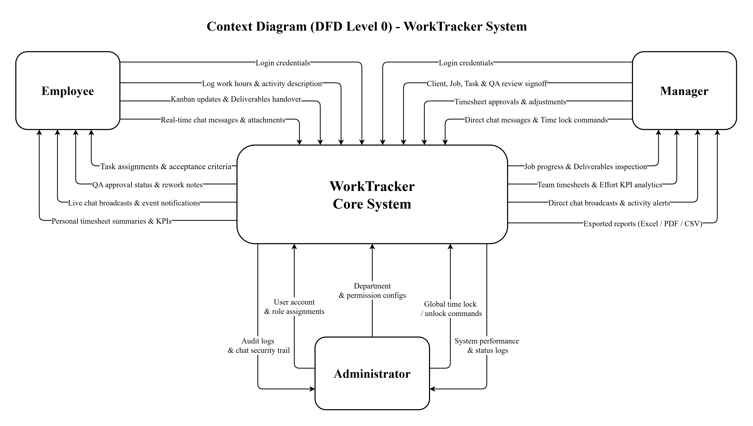
Figure 2.1: DFD Level 0 (Context Diagram) - Overall Data Flow of WorkTracker System
3.2 DFD Level 1
Diagram Description: DFD Level 1 decomposes the WorkTracker Core System into 4 Main Processing Subsystems:
1. Process 1.0 - User & Role Management: Receives login requests, verifies passwords, issues JWT tokens, manages 2-tier RBAC authorization, and handles account/department administration.
2. Process 2.0 - Job & Task Management: Processes Client creation (Clients), Project creation (Jobs), Task allocation (Tasks), Kanban status updates, comments, and document attachments.
3. Process 3.0 - Timesheet & Time Lock Management: Processes Log Work entries, validates 24h daily limit, manages timesheet approvals, and executes Time Lock/Unlock freezes (Job scope & Global scope).
4. Process 4.0 - Report, Analytics & Notification Management: Aggregates timesheet data, computes performance KPIs, exports personal/project reports, dispatches real-time notifications, and logs Audit Logs.
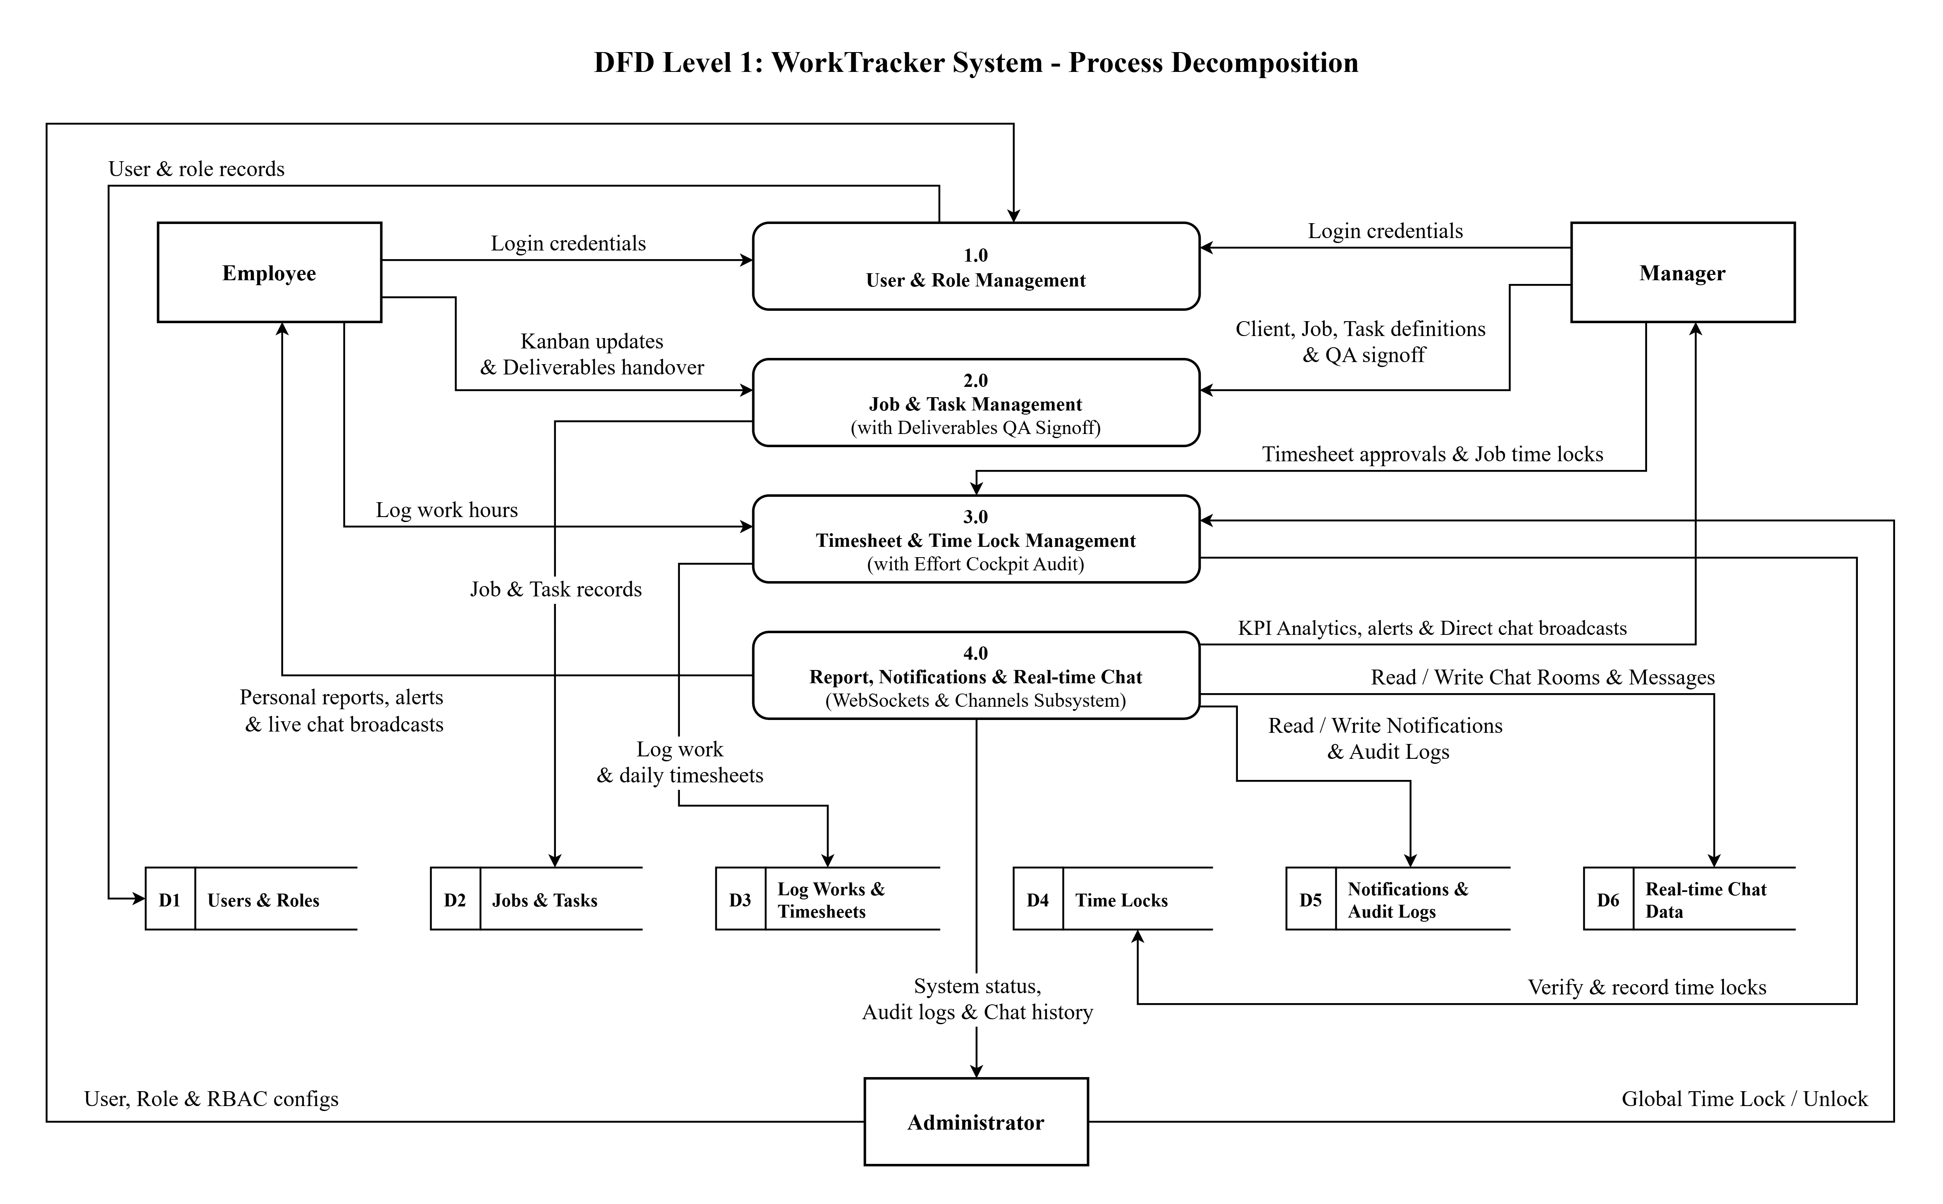
Figure 2.2: DFD Level 1 - Decomposition of 4 Core Functional Modules
3.3 DFD Level 2 - Process 1.0: User & Role Management
Diagram Description: DFD Level 2 decomposes Process 1.0 into 5 detailed sub-processes:
• 1.1 Create User Account: Receives account creation details from Admin and writes new record to Store D1 | Users & Roles.
• 1.2 Authenticate Login & JWT: Receives login credentials from Employee, Manager, Admin; validates against Store D1 and returns JWT authentication Token with permissions.
• 1.3 Assign Roles & Permissions: Receives authorization commands from Admin, configures roles (Admin, Manager, Employee) and detailed RBAC permissions in Store D1.
• 1.4 Manage User Profiles: Receives personal profile updates (phone, avatar, bio) from Employee/Manager or Department configurations from Admin, committing to Store D1.
• 1.5 Deactivate / Suspend Account: Receives account lock/unlock commands from Admin, updating is_active flag in Store D1 and logging audit trail in Store D5 | Notifications & Audit Logs.
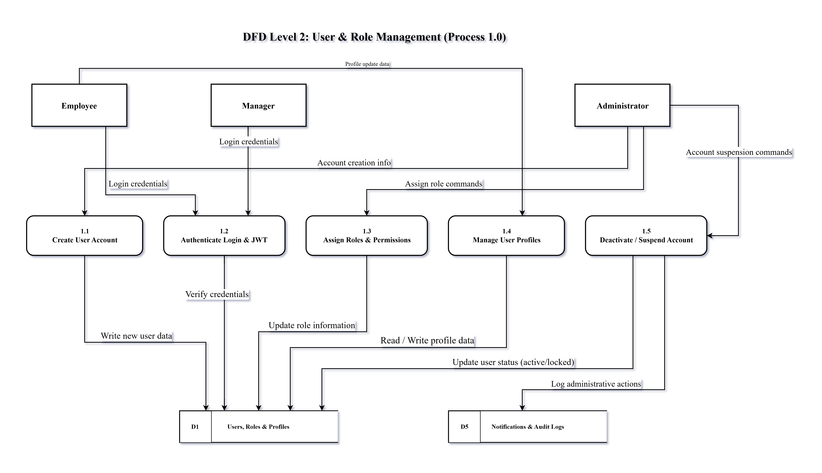
Figure 2.3: DFD Level 2 - Process 1.0: User & Role Management
3.4 DFD Level 2 - Process 2.0: Job & Task Management
Diagram Description: DFD Level 2 decomposes Process 2.0 into 4 detailed sub-processes:
• 2.1 Manage Clients & Create Jobs: Manager initializes Client profiles (clients) and Projects (jobs), storing in Store D2 | Jobs & Tasks.
• 2.2 Define & Assign Tasks: Manager defines task details, deadlines, priority, assignee (assignee_id), and followers (task_followers); reads user data from Store D1 and writes to Store D2.
• 2.3 Update Kanban & Submit Task: Employee drags-and-drops task cards across Kanban columns (TODO, IN_PROGRESS, REVIEW, DONE) and submits work; Manager approves or rejects; updates status in Store D2.
• 2.4 Task Discussions & Attachments: Employee and Manager post comments (task_comments) and upload file attachments (task_attachments), storing in Store D2; simultaneously triggering real-time notifications and audit logs in Store D5 | Notifications & Audit Logs.
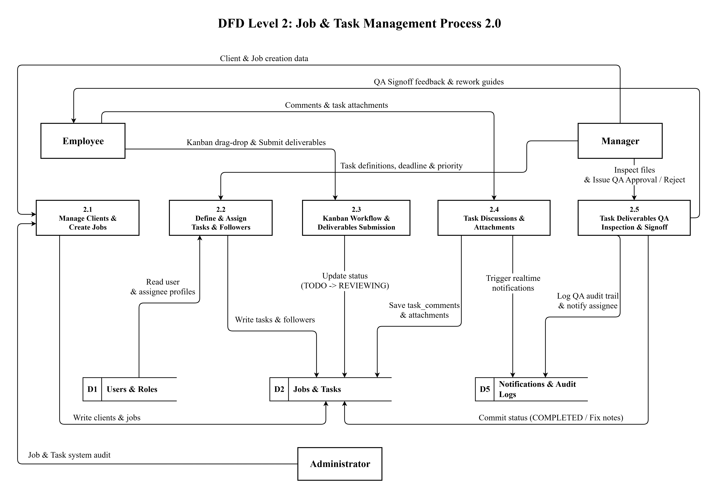
Figure 2.4: DFD Level 2 - Process 2.0: Job & Task Management
3.5 DFD Level 2 - Process 3.0: Timesheet & Time Lock Management
Diagram Description: DFD Level 2 decomposes Process 3.0 into 4 detailed sub-processes:
• 3.1 Receive & Validate Log Work Entry: Employee submits daily work log entry (work_date, hours_spent, description); process validates Task ID against Store D2 | Jobs & Tasks.
• 3.2 Check 24h Limit & Time Lock Constraints: Validates total daily work hours <= 24.0h (reading Store D3) and checks lock status (reading Store D4 | Time Locks). If valid, commits entry to Store D3 | Log Works & Timesheets.
• 3.3 Process Timesheet Approvals & Adjustments: Manager reviews, approves, or adjusts team work hour log entries, updating approval status in Store D3.
• 3.4 Execute Time Lock & Unlock Commands: Manager/Admin executes Time Lock or Unlock commands for Project or System scope, committing transaction to Store D4 | Time Locks and logging trail in Store D5 | Notifications & Audit Logs.
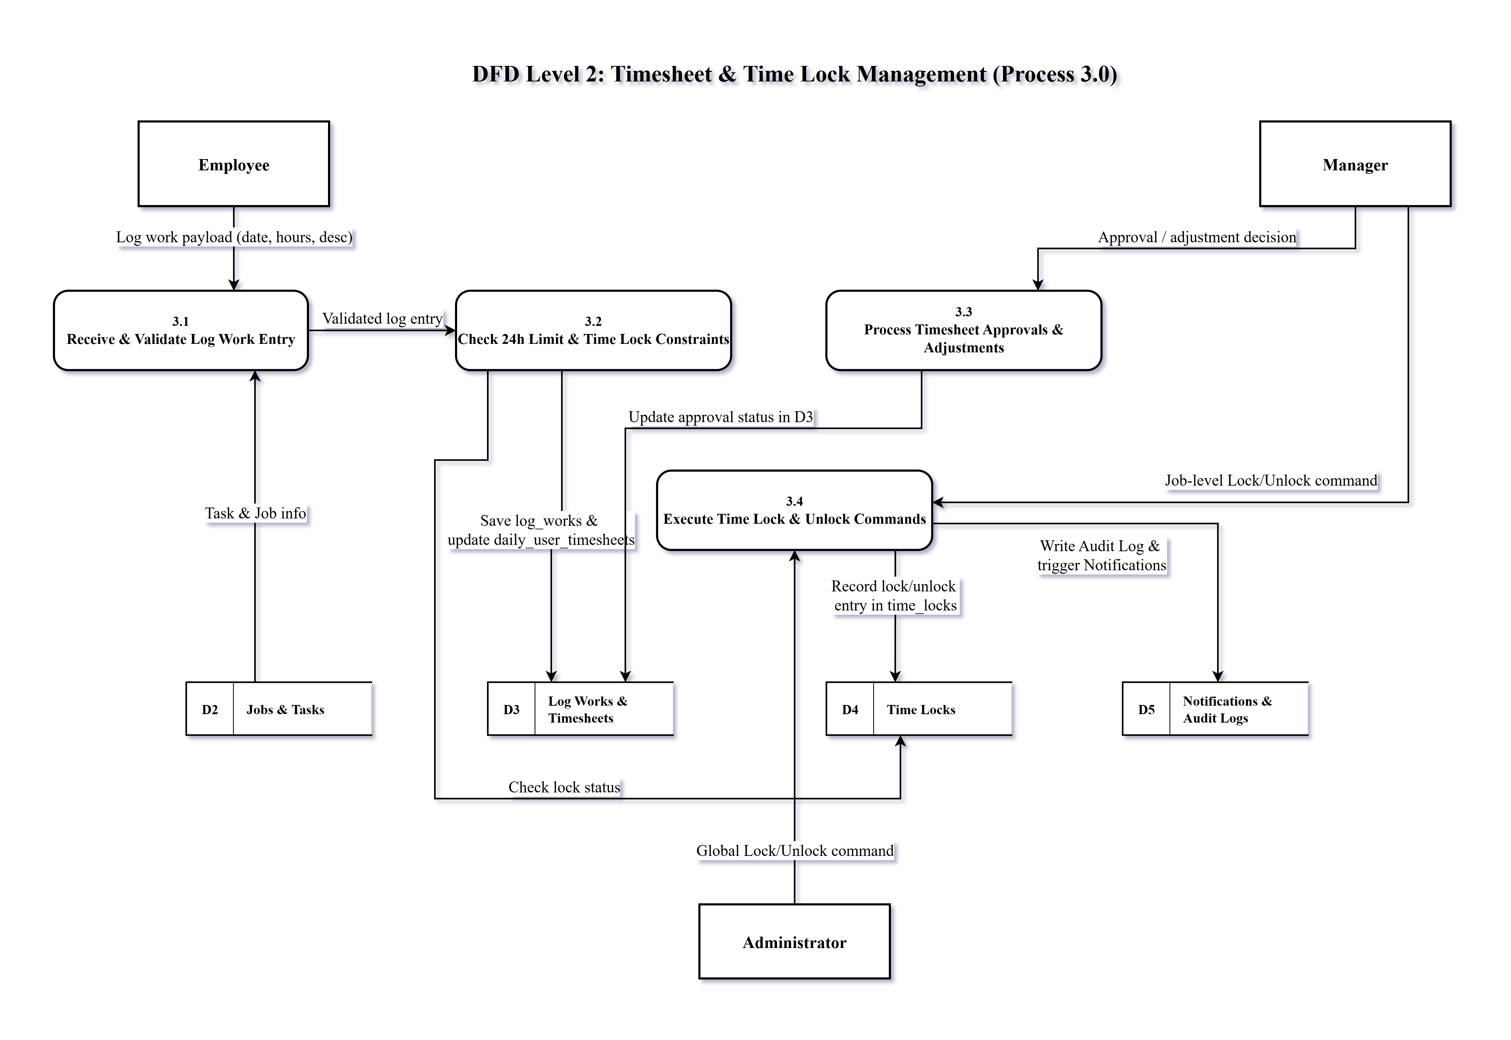
Figure 2.5: DFD Level 2 - Process 3.0: Timesheet & Time Lock Management
3.6 DFD Level 2 - Process 4.0: Report, Analytics & Notification Management
Diagram Description: DFD Level 2 decomposes Process 4.0 into 4 detailed sub-processes:
• 4.1 Aggregate Timesheet & Work Hours Data: Collects and aggregates work hour data from Store D3 and task data from Store D2.
• 4.2 Generate Project & Employee Reports: Reads employee/department data from Store D1 to generate personal timesheet reports for Employee and project/client work hour reports for Manager.
• 4.3 Compute Work Analytics & System KPIs: Computes performance KPIs, Time Lock compliance rates from Store D2 and Store D3, serving KPI Dashboard to Manager and Admin.
• 4.4 Dispatch Realtime Notifications & Audit Trail: Dispatches real-time/email notifications to Employee, Manager, Admin upon system events and logs audit trail in Store D5 | Notifications & Audit Logs.
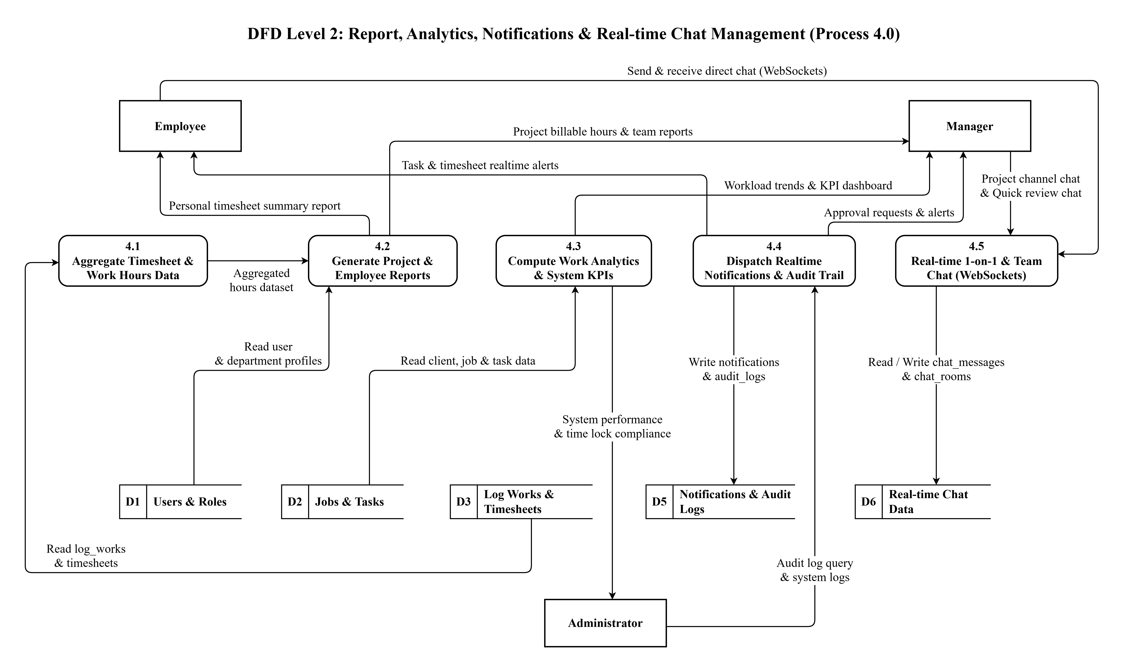
Figure 2.6: DFD Level 2 - Process 4.0: Report, Analytics & Notifications

4. ERD (Entity Relationship Diagram)
4.1 Entity Relationship Description
The following table details relationships and cardinality constraints among all 21 normalized PostgreSQL database entities in WorkTracker:
Table 1: Comprehensive Summary of Entity Relationships and Cardinalities across 21 WorkTracker Database Tables
Entity A | Entity B | Cardinality | Relationship Description
roles | role_permissions | 1 : N | One Role can be assigned multiple detailed Permissions via role_permissions mapping table.
permissions | role_permissions | 1 : N | One Permission code can belong to multiple different Roles within the system.
roles | users | 1 : N | One Role (Admin, Manager, Employee) is assigned to multiple user accounts (users).
users | departments | 1 : N | One user can act as Manager representing and leading a department (departments).
users | employee_profiles | 1 : 1 | One user account (users) owns exactly one detailed employee profile (employee_profiles).
departments | employee_profiles | 1 : N | One department (departments) contains multiple employee profiles (employee_profiles) belonging to that department.
clients | jobs | 1 : N | One Client (clients) can have multiple projects (jobs) executed within the system.
users | jobs | 1 : N | One Manager user (users) directly manages multiple projects (jobs).
jobs | tasks | 1 : N | One project (jobs) includes multiple detailed tasks (tasks) assigned to team members.
users | tasks (Assignee) | 1 : N | One Employee (users) can be assigned to perform multiple tasks (tasks).
users | tasks (Creator) | 1 : N | One user (users) can create and assign multiple tasks (tasks) to colleagues.
tasks | task_followers | 1 : N | One task (tasks) can have multiple followers (task_followers) receiving event notifications.
users | task_followers | 1 : N | One user (users) can subscribe to follow multiple different tasks in the system.
tasks | task_comments | 1 : N | One task (tasks) contains multiple discussion comments (task_comments) from team members.
users | task_comments | 1 : N | One user (users) can post multiple comments across various tasks.
tasks | log_works | 1 : N | One task (tasks) records multiple work hour entries (Log Work) submitted by employees.
users | log_works | 1 : N | One employee (users) executes multiple daily work hour log entries.
users | daily_user_timesheets | 1 : N | One employee (users) has multiple daily aggregated timesheet records.
jobs | time_locks | 1 : N | One project (jobs) can have timesheet period lock records (time_locks) applied monthly/yearly.
users | time_locks | 1 : N | One Manager/Admin user (users) executes Time Lock or Unlock operations.
users | audit_logs | 1 : N | One user (users) executes operations recorded in system audit logs.
users | notifications | 1 : N | One user (users) receives multiple system notifications and emails.
tasks | task_attachments | 1 : N | One task (tasks) contains multiple attached document/image files (task_attachments).
users | task_attachments | 1 : N | One user (users) uploads multiple attachment files for tasks.
jobs | chat_rooms | 1 : N | One project (jobs) can contain multiple dedicated team chat channels (chat_rooms) when room_type='JOB'.
chat_rooms | chat_participants | 1 : N | One chat room (chat_rooms) includes multiple participating members (chat_participants).
users | chat_participants | 1 : N | One user account (users) can join and participate in multiple 1-on-1 direct rooms and project channels.
chat_rooms | chat_messages | 1 : N | One chat room (chat_rooms) contains an ongoing stream of real-time text messages and shared file attachments (chat_messages).
users | chat_messages | 1 : N | One user account (users) can send multiple chat messages across various active conversation channels.
4.2 Overview Entity Relationship Diagram
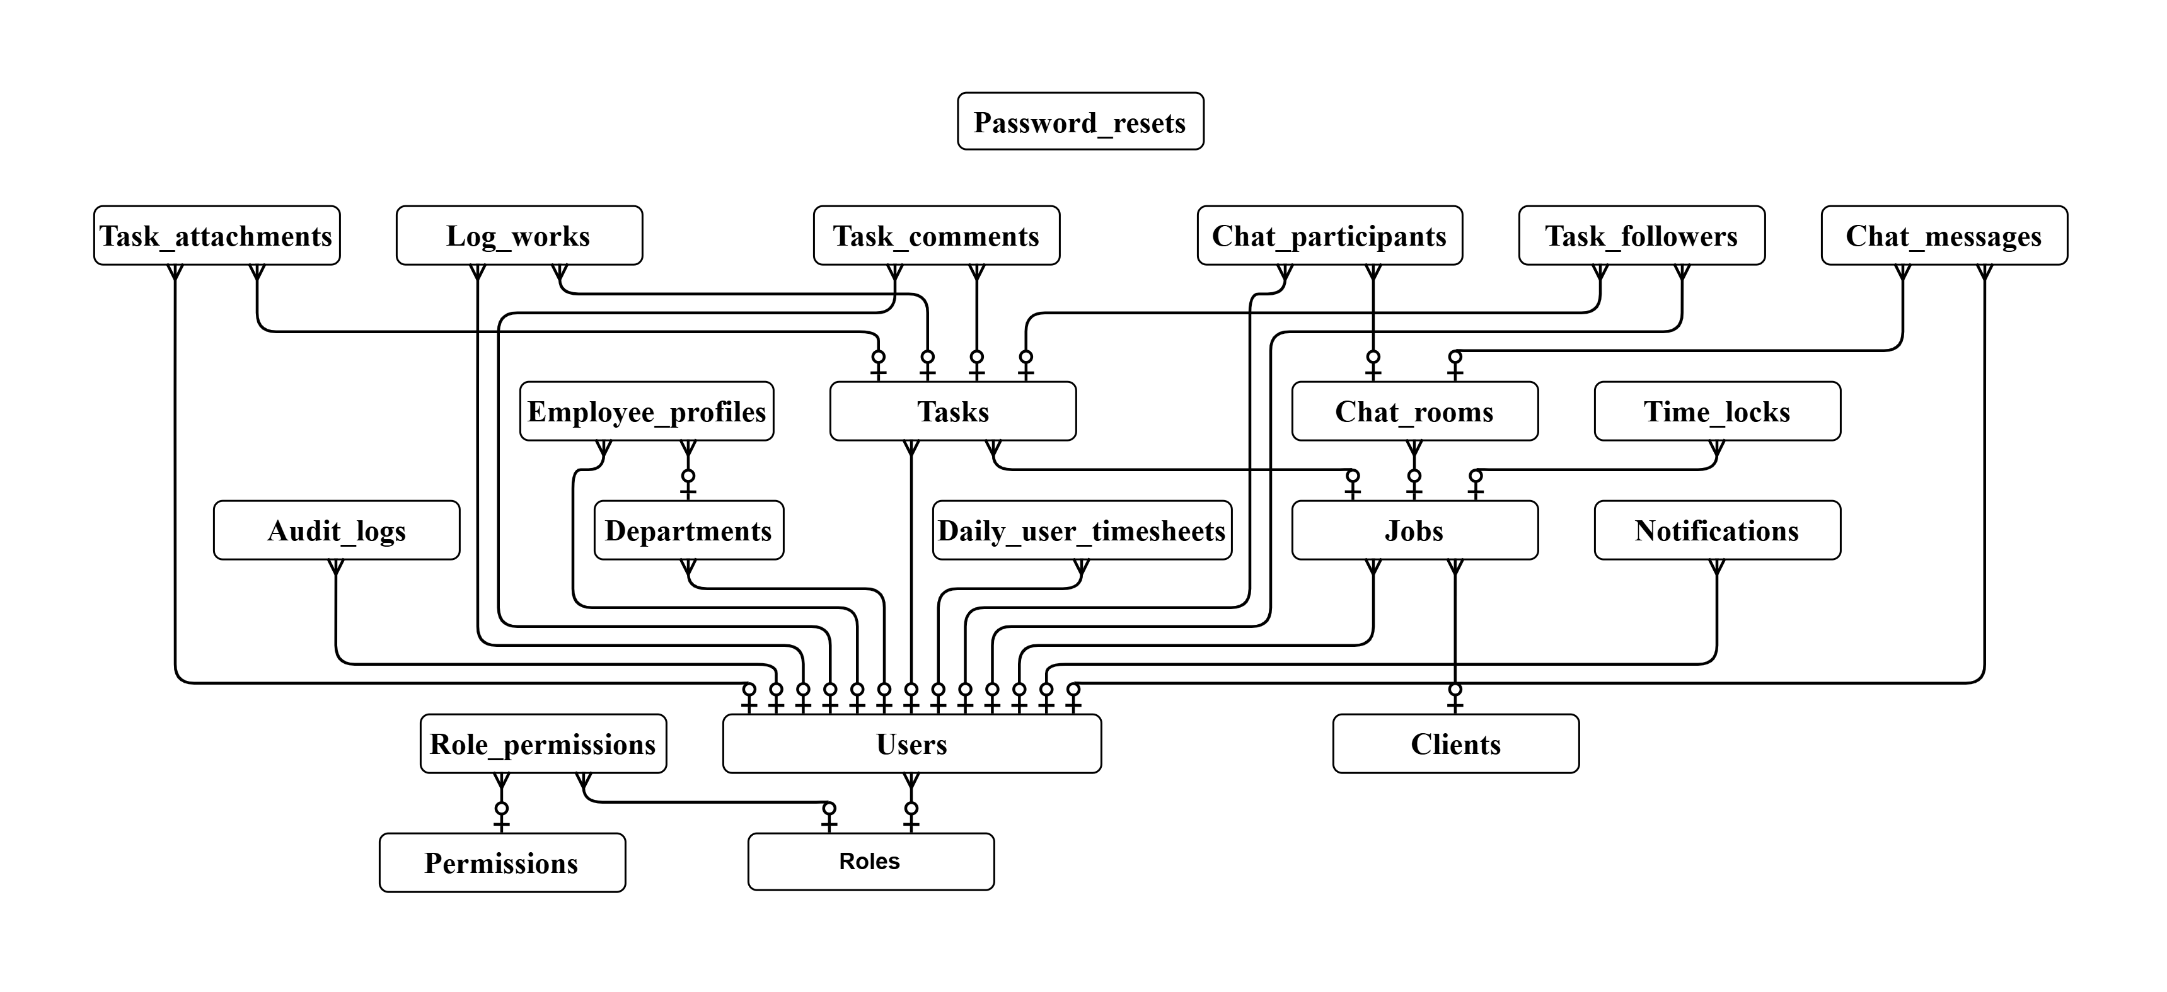
Note: Overview ERD illustrates the structural schema of 21 database entities and table relationships.

5. Database Data Dictionary (21 Relational Tables)
The WorkTracker system utilizes 21 normalized PostgreSQL relational database tables designed adhering to Third Normal Form (3NF), including core entities, RBAC access control, project tracking, timesheet governance, and real-time chat subsystems as follows:
1. roles Table (4 columns)
Table 2: Data Dictionary - Structure of roles Table (Role Management)
Column Name | Data Type | Constraint / Key | Description
id | INT | PRIMARY KEY, AUTO_INCREMENT | Unique role identifier.
code | VARCHAR(50) | NOT NULL, UNIQUE, INDEX | Role code used by backend logic, such as ADMIN, MANAGER, EMPLOYEE.
name | VARCHAR(100) | NOT NULL | Role display name shown on the user interface.
description | VARCHAR(255) | NULL | Description of the role and its responsibility.
2. permissions Table (3 columns)
Table 3: Data Dictionary - Structure of permissions Table (Permission Catalogue)
Column Name | Data Type | Constraint / Key | Description
id | INT | PRIMARY KEY, AUTO_INCREMENT | Unique permission identifier.
code | VARCHAR(100) | NOT NULL, UNIQUE, INDEX | Permission code used to protect backend actions.
name | VARCHAR(150) | NOT NULL | Human-readable permission name.
3. role_permissions Table (3 columns)
Table 4: Data Dictionary - Structure of role_permissions Table (Role-Permission Mapping)
Column Name | Data Type | Constraint / Key | Description
id | INT | PRIMARY KEY, AUTO_INCREMENT | Unique role-permission mapping identifier.
role_id | INT | NOT NULL, FOREIGN KEY | References roles(id).
permission_id | INT | NOT NULL, FOREIGN KEY | References permissions(id).
4. users Table (5 columns)
Table 5: Data Dictionary - Structure of users Table (User Accounts)
Column Name | Data Type | Constraint / Key | Description
id | INT | PRIMARY KEY, AUTO_INCREMENT | Unique user identifier.
email | VARCHAR(155) | NOT NULL, UNIQUE, INDEX | Main login email of the user.
password | VARCHAR(255) | NOT NULL | Hashed password.
role_id | INT | NOT NULL, FOREIGN KEY | References roles(id).
is_active | BOOLEAN | DEFAULT TRUE, INDEX | Account status used to allow or block system access.
5. password_resets Table (6 columns)
Table 6: Data Dictionary - Structure of password_resets Table (Password Reset Requests)
Column Name | Data Type | Constraint / Key | Description
id | INT | PRIMARY KEY, AUTO_INCREMENT | Unique password reset record identifier.
email | VARCHAR(155) | NOT NULL, INDEX | Email address requesting password reset.
token | VARCHAR(255) | NOT NULL, UNIQUE, INDEX | Secure one-time reset token.
is_used | TINYINT(1) | DEFAULT 0 | Indicates whether the token has already been used.
expires_at | DATETIME | NOT NULL | Token expiration time.
created_at | DATETIME | DEFAULT CURRENT_TIMESTAMP | Token creation time.
6. departments Table (5 columns)
Table 7: Data Dictionary - Structure of departments Table (Department Directory)
Column Name | Data Type | Constraint / Key | Description
id | INT | PRIMARY KEY, AUTO_INCREMENT | Unique department identifier.
manager_id | INT | NULL, FOREIGN KEY | References users(id) as the department manager.
name | VARCHAR(100) | NOT NULL, UNIQUE | Department name.
description | TEXT | NULL | Department description.
created_at | DATETIME | DEFAULT CURRENT_TIMESTAMP | Department creation time.
7. employee_profiles Table (6 columns)
Table 8: Data Dictionary - Structure of employee_profiles Table (Personnel Details)
Column Name | Data Type | Constraint / Key | Description
user_id | INT | PRIMARY KEY, FOREIGN KEY | References users(id). Also acts as the primary key.
full_name | VARCHAR(150) | NOT NULL | Employee full name.
phone_number | VARCHAR(20) | NULL | Employee phone number.
department_id | INT | NULL, FOREIGN KEY | References departments(id).
avatar_url | VARCHAR(500) | NULL | URL of the employee avatar image.
updated_at | DATETIME | DEFAULT CURRENT_TIMESTAMP ON UPDATE CURRENT_TIMESTAMP | Last profile update time.
8. clients Table (7 columns)
Table 9: Data Dictionary - Structure of clients Table (Client Directory)
Column Name | Data Type | Constraint / Key | Description
id | INT | PRIMARY KEY, AUTO_INCREMENT | Unique client identifier.
client_name | VARCHAR(255) | NOT NULL | Client or partner name.
tax_code | VARCHAR(50) | NOT NULL, UNIQUE, INDEX | Client tax code.
contact_person | VARCHAR(150) | NULL | Main contact person.
contact_email | VARCHAR(155) | NULL | Contact email.
contact_phone | VARCHAR(20) | NULL | Contact phone number.
is_active | TINYINT(1) | DEFAULT 1, INDEX | Client active status for soft delete.
9. jobs Table (10 columns)
Table 10: Data Dictionary - Structure of jobs Table (Core Projects/Jobs)
Column Name | Data Type | Constraint / Key | Description
id | INT | PRIMARY KEY, AUTO_INCREMENT | Unique job identifier.
client_id | INT | NOT NULL, FOREIGN KEY | References clients(id).
manager_id | INT | NOT NULL, FOREIGN KEY | References users(id) as the responsible manager.
job_name | VARCHAR(255) | NOT NULL | Job or project name.
description | TEXT | NULL | Job description.
start_date | DATE | NOT NULL | Job start date.
deadline | DATE | NOT NULL, INDEX | Job deadline.
status | ENUM | DEFAULT 'PLANNING' | Job status: PLANNING, ACTIVE, COMPLETED, ON_HOLD, CANCELLED.
created_at | DATETIME | DEFAULT CURRENT_TIMESTAMP | Job creation time.
updated_at | DATETIME | DEFAULT CURRENT_TIMESTAMP | Last job update time.
10. time_locks Table (13 columns)
Table 11: Data Dictionary - Structure of time_locks Table (Timesheet Period Locks)
Column Name | Data Type | Constraint / Key | Description
id | INT | PRIMARY KEY, AUTO_INCREMENT | Unique time lock identifier.
lock_month | TINYINT | NOT NULL | Locked month, from 1 to 12.
lock_year | SMALLINT | NOT NULL | Locked year.
lock_scope | ENUM | NOT NULL, DEFAULT 'JOB' | Scope of the lock: JOB (restricted to one specific job) or GLOBAL (system-wide, all jobs).
job_id | INT | NULL, FOREIGN KEY | References jobs(id). Required when lock_scope = JOB; NULL when lock_scope = GLOBAL.
is_locked | TINYINT(1) | DEFAULT 1 | Indicates whether the period is locked.
locked_by | INT | NOT NULL, FOREIGN KEY | References users(id) as the user who locked the period.
locked_at | DATETIME | DEFAULT CURRENT_TIMESTAMP | Lock action time.
lock_reason | TEXT | NULL | Reason for locking the timesheet period.
unlocked_by | INT | NULL, FOREIGN KEY | References users(id) as the user who last unlocked the period.
unlocked_at | DATETIME | NULL | Time when the period was last unlocked.
unlock_reason | TEXT | NULL | Reason for unlocking the timesheet period. Required when a locked period is unlocked.
updated_at | DATETIME | DEFAULT CURRENT_TIMESTAMP | Last time the lock record was changed.
11. audit_logs Table (9 columns)
Table 12: Data Dictionary - Structure of audit_logs Table (System Audit Logs)
Column Name | Data Type | Constraint / Key | Description
id | BIGINT | PRIMARY KEY, AUTO_INCREMENT | Unique audit log identifier. BIGINT is used for large log volume.
user_id | INT | NULL, FOREIGN KEY | References users(id). May be NULL if the referenced user is unavailable.
action | VARCHAR(50) | NOT NULL | Action name, such as CREATE_JOB, SOFT_DELETE_CLIENT, or LOCK_TIMESHEET.
table_name | VARCHAR(50) | NOT NULL | Name of the affected table.
record_id | INT | NOT NULL | ID of the affected record.
old_values | JSON | NULL | Data before the change.
new_values | JSON | NULL | Data after the change.
ip_address | VARCHAR(45) | NULL | IP address of the actor, when available from the request context.
created_at | DATETIME | DEFAULT CURRENT_TIMESTAMP, INDEX | Audit log creation time.
12. tasks Table (13 columns)
Table 13: Data Dictionary - Structure of tasks Table (Work Items & Tasks)
Column Name | Data Type | Constraint / Key | Description
id | INT | PRIMARY KEY, AUTO_INCREMENT | Unique task identifier.
job_id | INT | NOT NULL, FOREIGN KEY | References jobs(id).
assignee_id | INT | NOT NULL, FOREIGN KEY | References users(id) as the assigned employee.
creator_id | INT | NOT NULL, FOREIGN KEY | References users(id) as the task creator.
title | VARCHAR(255) | NOT NULL | Task title.
description | TEXT | NULL | Task description.
priority | ENUM | DEFAULT 'MEDIUM', INDEX | Task priority: LOW, MEDIUM, HIGH.
status | ENUM | DEFAULT 'TODO', INDEX | Task status: TODO, IN_PROGRESS, REVIEWING, COMPLETED, CANCELLED.
deadline | DATE | NOT NULL, INDEX | Task deadline.
completed_at | DATETIME | NULL | Completion time when the task is approved as completed.
order_index | VARCHAR(255) | NOT NULL, INDEX | String-based ordering value for Kanban drag-and-drop.
created_at | DATETIME | DEFAULT CURRENT_TIMESTAMP | Task creation time.
updated_at | DATETIME | DEFAULT CURRENT_TIMESTAMP | Last task update time.
13. task_followers Table (4 columns)
Table 14: Data Dictionary - Structure of task_followers Table (Task Followers)
Column Name | Data Type | Constraint / Key | Description
id | INT | PRIMARY KEY, AUTO_INCREMENT | Unique follower record identifier.
task_id | INT | NOT NULL, FOREIGN KEY | References tasks(id).
user_id | INT | NOT NULL, FOREIGN KEY | References users(id).
joined_at | DATETIME | DEFAULT CURRENT_TIMESTAMP | Time when the user started following the task.
14. task_comments Table (6 columns)
Table 15: Data Dictionary - Structure of task_comments Table (Task Discussions)
Column Name | Data Type | Constraint / Key | Description
id | INT | PRIMARY KEY, AUTO_INCREMENT | Unique comment identifier.
task_id | INT | NOT NULL, FOREIGN KEY | References tasks(id).
user_id | INT | NOT NULL, FOREIGN KEY | References users(id) as the comment author.
content | TEXT | NOT NULL | Comment content.
comment_type | ENUM | NOT NULL, DEFAULT 'NORMAL' | Distinguishes comment purpose: NORMAL (regular discussion) or REJECTION_NOTE (Manager rejection reason).
created_at | DATETIME | DEFAULT CURRENT_TIMESTAMP, INDEX | Comment creation time.
15. log_works Table (15 columns)
Table 16: Data Dictionary - Structure of log_works Table (Work Hours Log)
Column Name | Data Type | Constraint / Key | Description
id | BIGINT | PRIMARY KEY, AUTO_INCREMENT | Unique log work identifier. BIGINT is used because timesheet records may grow quickly.
task_id | INT | NOT NULL, FOREIGN KEY | References tasks(id).
user_id | INT | NOT NULL, FOREIGN KEY | References users(id).
work_date | DATE | NOT NULL | Date when the work was performed.
hours_spent | DECIMAL(4,2) | NOT NULL | Number of hours spent on the task.
description | TEXT | NULL | Description of work performed.
created_at | DATETIME | DEFAULT CURRENT_TIMESTAMP | Log creation time.
updated_at | DATETIME | DEFAULT CURRENT_TIMESTAMP | Last log update time.
review_status | ENUM | NOT NULL, DEFAULT 'PENDING', INDEX | Review state of the log work entry: PENDING, APPROVED, REJECTED, VOIDED.
reviewed_by | INT | NULL, FOREIGN KEY | References users(id) as the Manager who reviewed this entry.
reviewed_at | DATETIME | NULL | Time when the entry was reviewed.
review_note | TEXT | NULL | Manager's note when approving or rejecting the entry.
adjusted_by | INT | NULL, FOREIGN KEY | References users(id) as the user who corrected or voided this entry.
adjusted_at | DATETIME | NULL | Time when the entry was corrected or voided.
adjustment_reason | TEXT | NULL | Reason for correction or voiding, required for audit traceability.
16. daily_user_timesheets Table (4 columns)
Table 17: Data Dictionary - Structure of daily_user_timesheets Table (Daily Timesheets)
Column Name | Data Type | Constraint / Key | Description
id | INT | PRIMARY KEY, AUTO_INCREMENT | Unique daily timesheet record identifier.
user_id | INT | NOT NULL, FOREIGN KEY | References users(id).
work_date | DATE | NOT NULL | Work date.
total_hours | DECIMAL(4,2) | DEFAULT 0, CHECK total_hours <= 24 | Total logged hours of the user on the date.
17. notifications Table (11 columns)
Table 18: Data Dictionary - Structure of notifications Table (System Notifications)
Column Name | Data Type | Constraint / Key | Description
id | BIGINT | PRIMARY KEY, AUTO_INCREMENT | Unique notification identifier.
user_id | INT | NOT NULL, INDEX, FOREIGN KEY | References users(id) as the notification receiver.
event_type | VARCHAR(50) | NOT NULL, INDEX | Business event code (TASK_ASSIGNED, TIMESHEET_LOCK, etc.).
type | VARCHAR(50) | NOT NULL | Delivery channel: SYSTEM_ONLY, EMAIL_ONLY, or ALL.
title | VARCHAR(255) | NOT NULL | Notification title.
content | TEXT | NULL | Notification message content.
related_url | VARCHAR(255) | NULL | Redirect URL.
is_read | TINYINT(1) | DEFAULT 0 | Read status.
is_sent_email | TINYINT(1) | DEFAULT 0 | Email delivery status.
sent_at | DATETIME | NULL | Email sent time.
created_at | DATETIME | DEFAULT CURRENT_TIMESTAMP, INDEX | Notification creation time.
18. task_attachments Table (7 columns)
Table 19: Data Dictionary - Structure of task_attachments Table (Task Attachments)
Column Name | Data Type | Constraint / Key | Description
id | INT | PRIMARY KEY, AUTO_INCREMENT | Unique attachment identifier.
task_id | INT | NOT NULL, FOREIGN KEY | References tasks(id).
user_id | INT | NOT NULL, FOREIGN KEY | References users(id) as the uploader.
file_name | VARCHAR(255) | NOT NULL | Original file name.
file_url | VARCHAR(500) | NOT NULL | File storage URL.
file_size | INT | NULL | File size in bytes.
uploaded_at | DATETIME | DEFAULT CURRENT_TIMESTAMP | Upload time.
19. chat_rooms Table (6 columns)
Table 20: Data Dictionary - Structure of chat_rooms Table (Chat Rooms & Channels)
Column Name | Data Type | Constraint / Key | Description
id | INT | PRIMARY KEY, AUTO_INCREMENT | Unique chat room identifier.
room_type | VARCHAR(10) | NOT NULL, INDEX | Room classification: 'JOB' (Project Channel) or 'DIRECT' (1-on-1).
job_id | INT | NULL, FOREIGN KEY | References jobs(id). Associated project if room_type is 'JOB'.
name | VARCHAR(255) | NULL | Display name of the chat channel or 1-on-1 room descriptor.
created_at | DATETIME | NOT NULL, DEFAULT NOW | Timestamp when the room was initialized.
updated_at | DATETIME | NOT NULL, DEFAULT NOW | Timestamp of the latest message activity in the room.
20. chat_participants Table (5 columns)
Table 21: Data Dictionary - Structure of chat_participants Table (Room Members & Read Status)
Column Name | Data Type | Constraint / Key | Description
id | INT | PRIMARY KEY, AUTO_INCREMENT | Unique participant record identifier.
room_id | INT | NOT NULL, FOREIGN KEY | References chat_rooms(id). CASCADE on room deletion.
user_id | INT | NOT NULL, FOREIGN KEY | References users(id). Member participating in the chat room.
last_read_at | DATETIME | NOT NULL, DEFAULT NOW | Timestamp tracking last read message for unread badge counts.
joined_at | DATETIME | NOT NULL, DEFAULT NOW | Timestamp when the user joined the room.
21. chat_messages Table (8 columns)
Table 22: Data Dictionary - Structure of chat_messages Table (Real-time Chat Messages)
Column Name | Data Type | Constraint / Key | Description
id | BIGINT | PRIMARY KEY, AUTO_INCREMENT | Unique chat message identifier.
room_id | INT | NOT NULL, FOREIGN KEY | References chat_rooms(id). CASCADE on room deletion.
sender_id | INT | NOT NULL, FOREIGN KEY | References users(id). Author of the sent message.
content | TEXT | DEFAULT '' | Text message body content.
attachment_url | VARCHAR(500) | NULL | URL path to uploaded file attachment if applicable.
attachment_name | VARCHAR(255) | NULL | Original filename of the attached deliverable/document.
attachment_size | INT | NULL | Size of the attached file in bytes.
created_at | DATETIME | NOT NULL, INDEX | Timestamp when message was sent and broadcasted.

6. Software Architecture
6.1 Overall System Architecture
The WorkTracker system is built upon a Decoupled Client-Server Architecture interacting via standard RESTful API protocols and JSON data formatting.
• Backend Framework: Python 3.10+, Django Web Framework & Django REST Framework (DRF). Gunicorn / Waitress WSGI Server.
• Frontend Framework: React.js (Single Page Application - SPA), JavaScript (ES6+), Axios HTTP Client attaching JWT Bearer Token, React Router DOM.
• Database & Caching: PostgreSQL 14+ (Primary Relational Database), Redis Server 6+ (In-memory Caching & Task Queue Configuration).
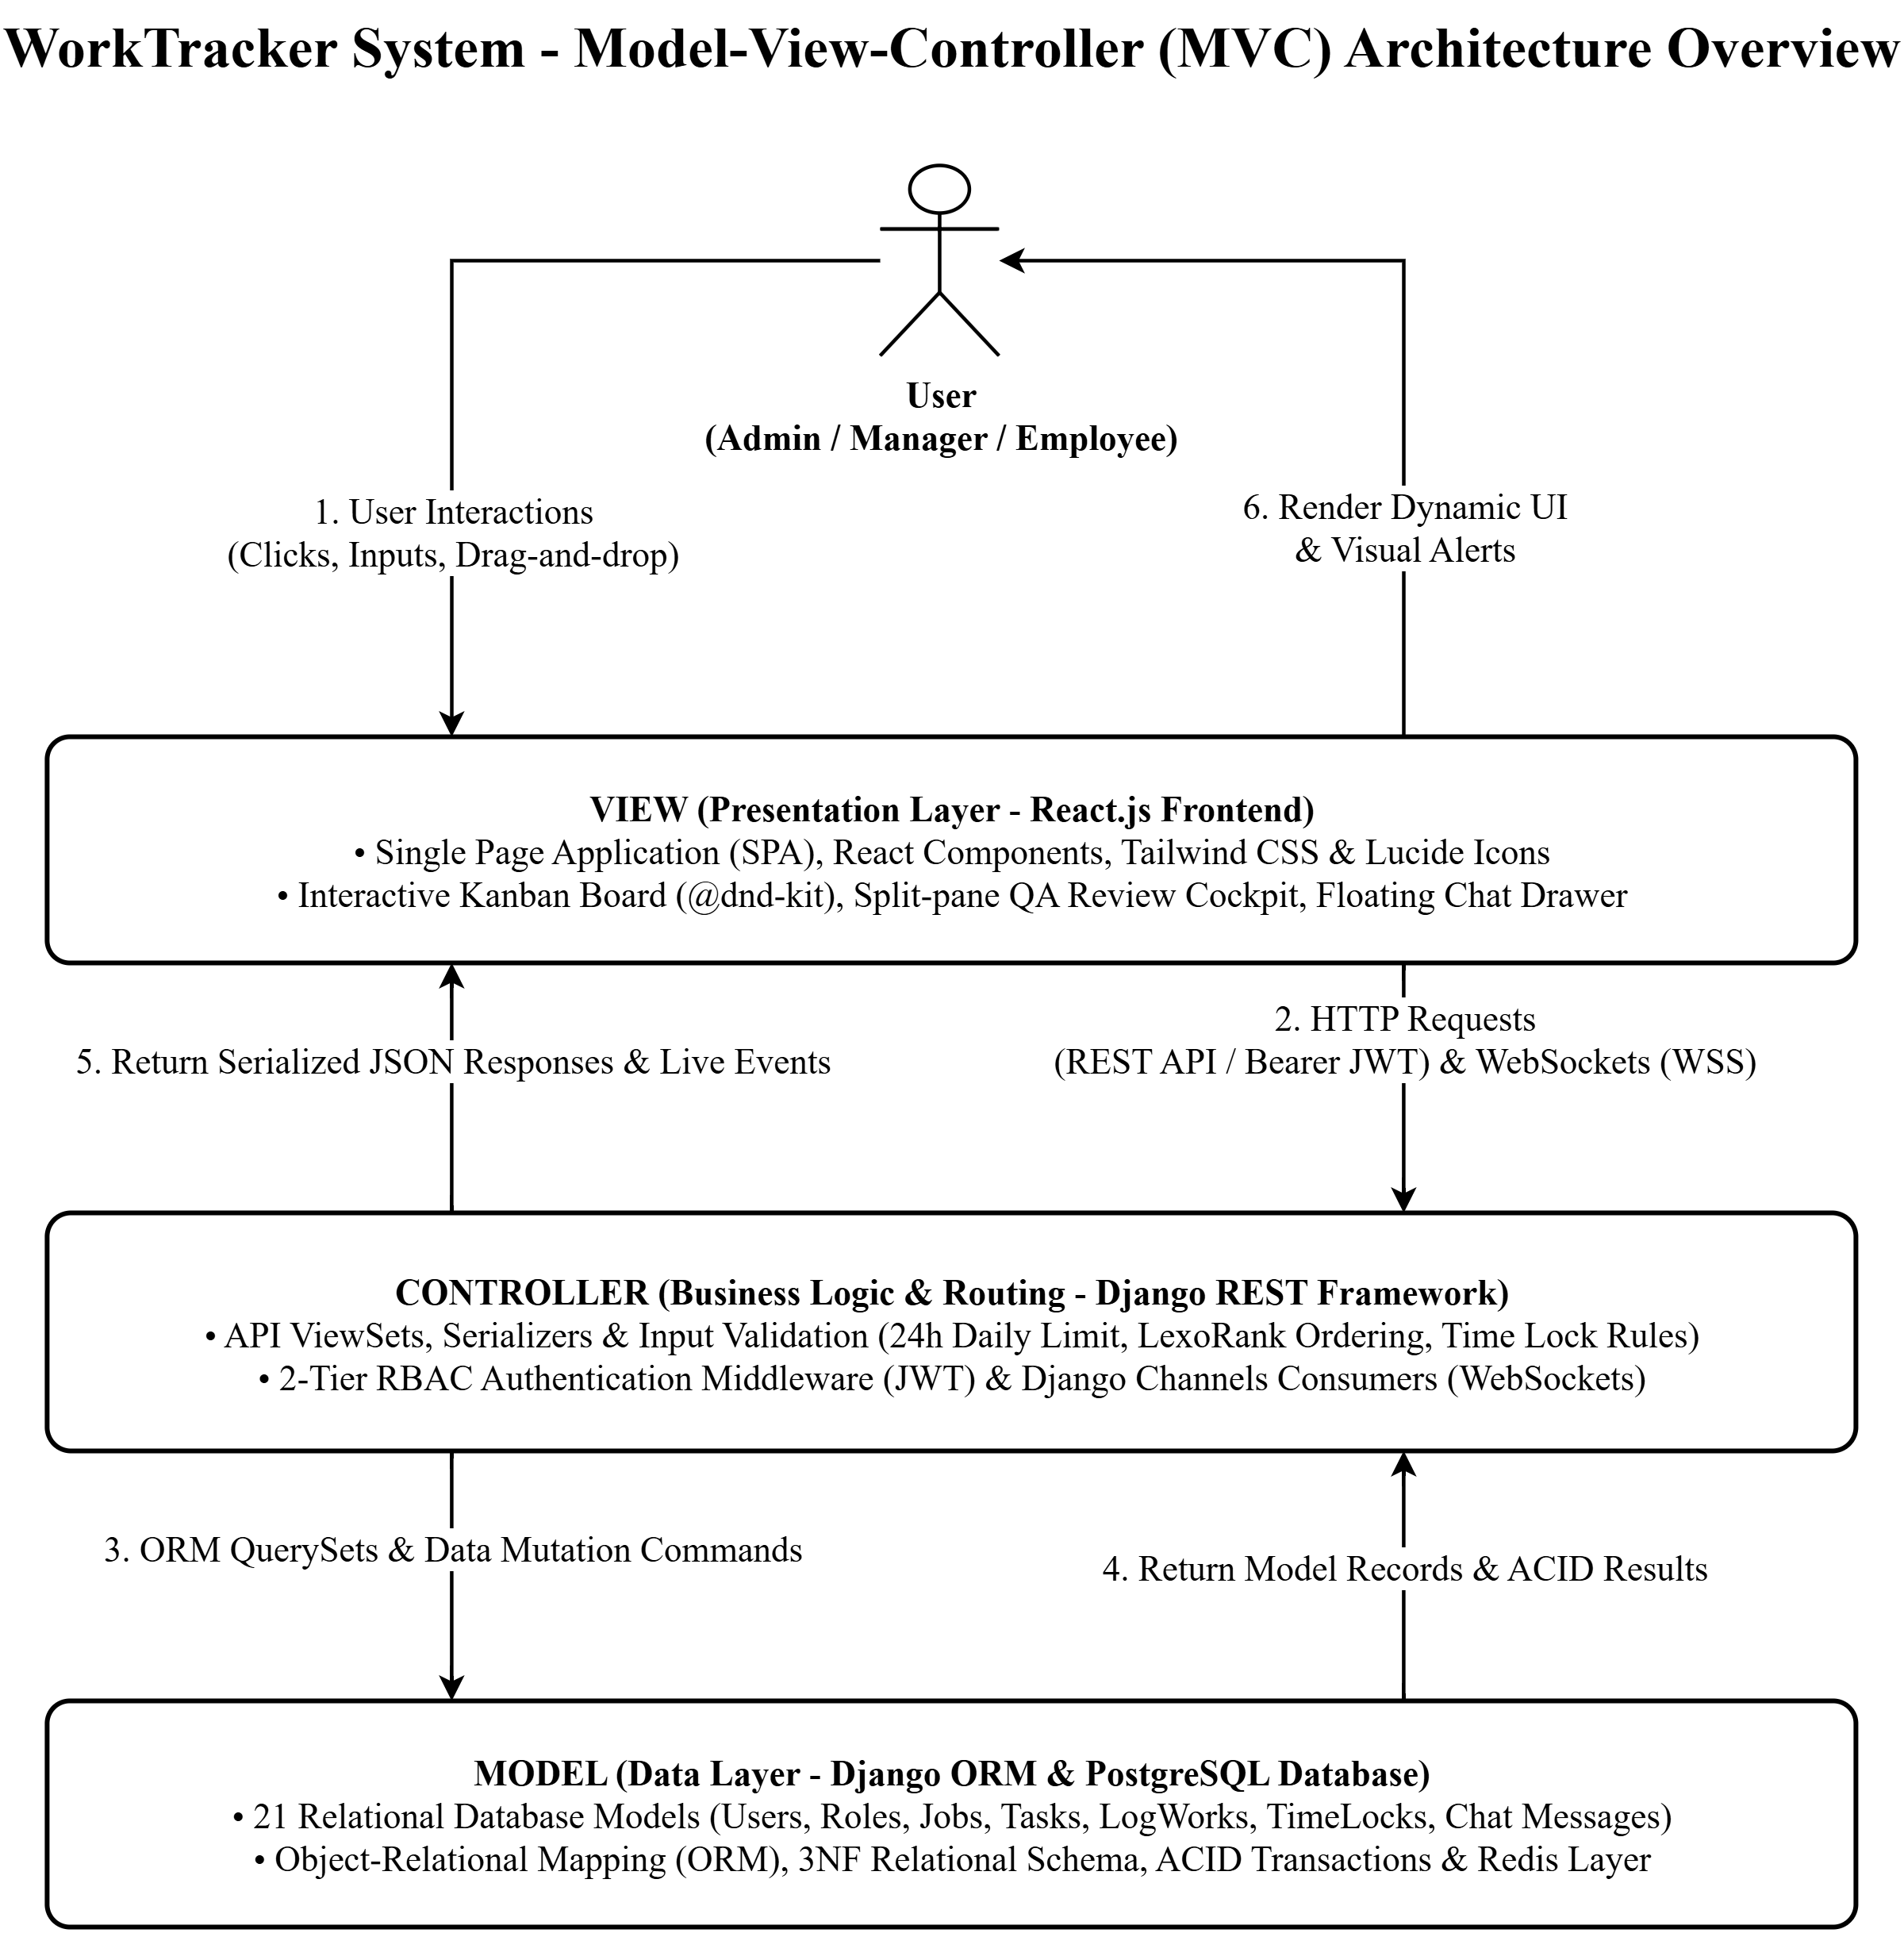
6.2 Frontend Architecture (React Framework)
• Core Tech: React.js (Single Page Application - SPA), JavaScript (ES6+), React Router DOM client-side routing.
• Directory Structure: - /components: Shared UI components (Buttons, Modals, Forms, Kanban Board). - /pages: Role-based views (Dashboard, Jobs, Tasks, Timesheets, Admin Settings). - /services: API HTTP client layer (Axios) auto-attaching JWT Bearer Token. - /context: Authentication state management (AuthContext) and notifications.
6.3 Backend Architecture (Django REST Framework)
• Core Tech: Python 3.x, Django Web Framework, Django REST Framework (DRF).
• Main Architecture Layers: - View/Serializer Layer: Handles incoming HTTP requests, validates input data, and serializes objects. - Permission Layer: Enforces 2-tier checks (Authentication check & Permission code validation). - Service/Business Logic Layer: Encapsulates complex business logic (24h log work limits, timesheet period lock logic). - ORM & Database Layer: Employs Django ORM communicating with PostgreSQL, ensuring ACID transaction integrity.
6.4 Real-time WebSockets & Channels Subsystem (ASGI & Redis)
The WorkTracker real-time messaging and live notification architecture is engineered using Django Channels over ASGI (Daphne server) integrated with Redis Channel Layer. This subsystem provides sub-100ms message delivery for 1-on-1 direct chat, project channel broadcasts, and instant task inspection discussions, with automatic reconnection, message deduplication, and full synchronization with REST API persistent endpoints.

7. Tasksheet 2 (Phase 2 Work Allocation & Member Details)
Description: Detailed work and progress allocation table for team members during Review 2 phase.
[Insertion Placeholder - Tasksheet 2 Work Allocation Table for Review 2]

PART 3: REVIEW 3 (PHASE 3 - UI SCREEN PREVIEW & FINALIZATION)

1. Snapshot screen design (Wireframe)
Description: Preliminary wireframe screen layout designs for the WorkTracker application prior to frontend implementation.
[Insertion Placeholder - Wireframe Image: Login Screen Layout] UI-UX Source File: docs/UI-UX/preview_login.html Description: Login interface wireframe layout detailing credential inputs and desktop action buttons.
[Insertion Placeholder - Wireframe Image: Change Password Screen Layout] UI-UX Source File: docs/UI-UX/preview_change_password.html Description: Personal password change wireframe screen layout.

2. Tasksheet review 3 (Details to member)
Description: Detailed task allocation and member contribution evaluation table for Review 3.
[Insertion Placeholder - Tasksheet Review 3 Table]

3. Snapshot (Actual System User Interface Screens)
Below are screenshots showcasing actual user interface screens of the WorkTracker system divided into three primary modules: Employee User Interface, Manager Project Interface, and Central Admin Web Dashboard.
3.1 Frontend: Full All Screens (Web App Interface - Employee & Manager)
A. Employee Interface Screens (EMPLOYEE Module)
[Screen: Employee Personal Dashboard] UI-UX Source File: docs/UI-UX/EMPLOYEE/Dashboard.jpg Description: Displays overview of work hours, personal task progress, and timesheet analytics charts.
[Screen: My Tasks List] UI-UX Source File: docs/UI-UX/EMPLOYEE/My_tasks.jpg Description: Displays assigned tasks directory showing status, priority levels, and deadlines.
[Screen: Log Work & Timesheet Management] UI-UX Source File: docs/UI-UX/EMPLOYEE/TimeSheet.jpg Description: Displays detailed daily timesheet table and Log Work entry modal form.
[Screen: My Performance Chart] UI-UX Source File: docs/UI-UX/EMPLOYEE/My_Performance.jpg Description: Displays work performance analytics charts and task completion rate metrics.
[Screen: Personal Profile] UI-UX Source File: docs/UI-UX/EMPLOYEE/Profile.png Description: Personal profile viewing and updating interface for avatar and contact phone.
[Screen: Notifications List] UI-UX Source File: docs/UI-UX/EMPLOYEE/notifications.jpg Description: Real-time notification inbox interface related to work activities.
B. Manager Interface Screens (MANAGER Module)
[Screen: Manager Dashboard] UI-UX Source File: docs/UI-UX/Manager/Dashboard.png Description: Displays overview of managed projects, team progress, and KPI metric cards.
[Screen: My Jobs List] UI-UX Source File: docs/UI-UX/Manager/Myjob.png Description: Displays projects directory managed directly by the Manager.
[Screen: Job Detail] UI-UX Source File: docs/UI-UX/Manager/Job Detail.png Description: Detailed project view showing task lists and timeframe budget.
[Screen: Kanban Task Board] UI-UX Source File: docs/UI-UX/Manager/Kanban Board.png Description: Interactive drag-and-drop Kanban board for visual task status management.
[Screen: Task Detail, Discussion & Attachments] UI-UX Source File: docs/UI-UX/Manager/Task Detail.png Description: Detailed task view with comment discussions and attachment file management.
[Screen: Team Members Management] UI-UX Source File: docs/UI-UX/Manager/Team Members.png Description: Department team members directory viewing and project assignment interface.
[Screen: Timesheet Review] UI-UX Source File: docs/UI-UX/Manager/Timesheet Review.png Description: Team work hours review and timesheet approval interface.
[Screen: Timesheet Period Lock Control] UI-UX Source File: docs/UI-UX/Manager/Time Lock.png Description: Monthly/yearly timesheet period lock execution interface for project scope.
[Screen: QA Review Queue & Deliverables Inspection]
UI-UX Source File: docs/UI-UX/Manager/Task_QA_Review.png
Description: Dedicated Tier-1 deliverables quality assurance review center featuring 2-column Split-Pane Master-Detail (56%/44%), 1-click deliverable package downloads, side-by-side Acceptance Criteria vs Handover Note audit, auto-advance queue signoff, and rejection modal with reference guideline file attachments.
[Screen: Real-time Team & 1-on-1 Chat Interface]
UI-UX Source File: docs/UI-UX/Manager/Team_Chat.png
Description: Persistent real-time team collaboration center supporting project channels, 1-on-1 direct employee messaging, live online presence, and instant floating quick chat during task review.
3.2 Backend / Admin: Governance Screens (Admin Web Dashboard)
The Admin Web Dashboard comprises governance screens dedicated to system Administrators.
[Screen: Admin System Governance Dashboard] UI-UX Source File: docs/UI-UX/ADMIN/preview_admin_dashboard.html Description: Displays company-wide governance overview covering all users, projects, and system activities.
[Screen: Admin Client Directory Management] UI-UX Source File: docs/UI-UX/ADMIN/admin_clients.png Description: Client directory creation and profile management interface (Clients).
[Screen: Admin System Audit Logs] UI-UX Source File: docs/UI-UX/ADMIN/admin_audit_logs.png Description: System-wide operation audit trail inspection interface (Audit Logs).
[Screen: Admin Employees & Personnel Management] UI-UX Source File: docs/UI-UX/ADMIN/preview_admin_employees.html Description: User account creation, role assignment, and activate/deactivate interface.
[Screen: Admin System Projects Management] UI-UX Source File: docs/UI-UX/ADMIN/preview_admin_jobs.html Description: System-wide projects monitoring and Manager assignment interface.
[Screen: Admin Global Time Lock Control] UI-UX Source File: docs/UI-UX/ADMIN/preview_admin_timesheet_control.html Description: System-wide timesheet period lock control interface (Global Scope).
[Screen: Admin Roles & RBAC Permissions Configuration] UI-UX Source File: docs/UI-UX/ADMIN/preview_admin_settings.html Description: Roles configuration and detailed RBAC permissions setup interface.

